2016-17
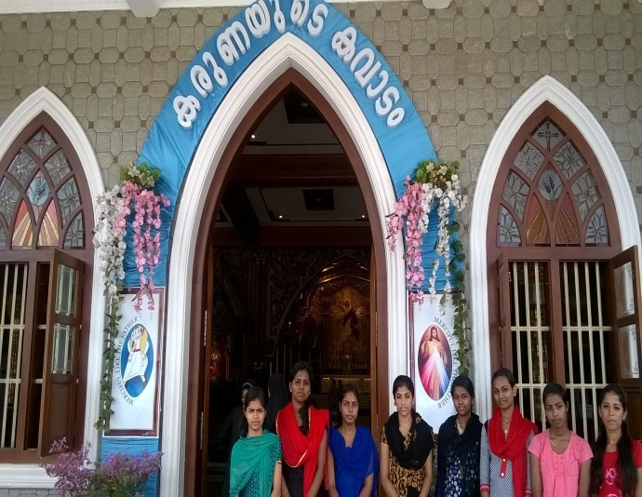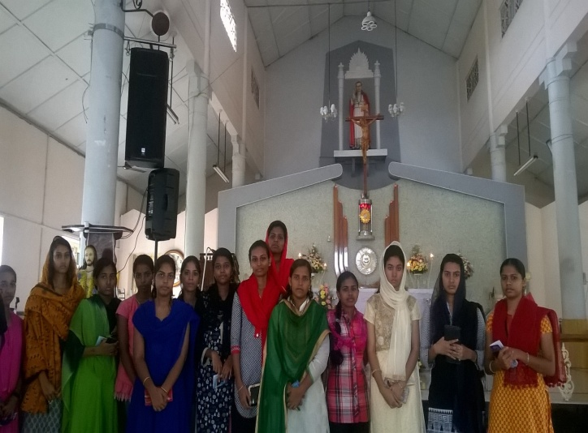
Visit to Holy Doors

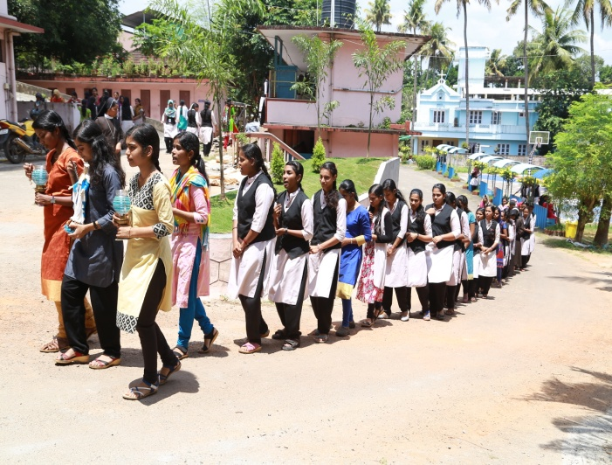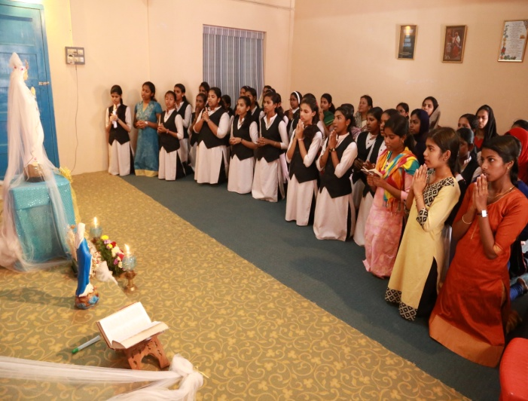
Rosary procession on 1st October

2015-16
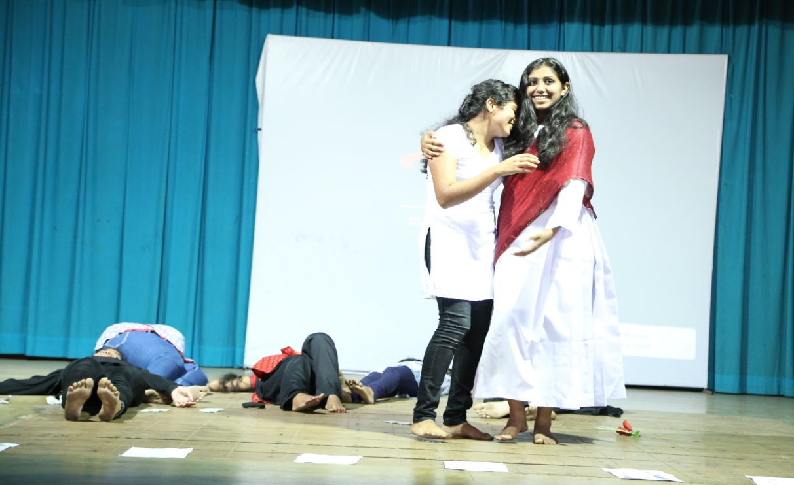
Jesus Youth presented a skit " Life House" on 20.07.15 for Welcoming the Freshers

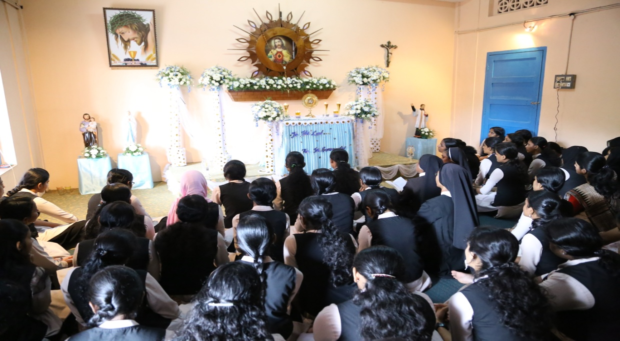
Jesus Youth organised Adoration on 27.07.15 in the prayer room for Students and Staff
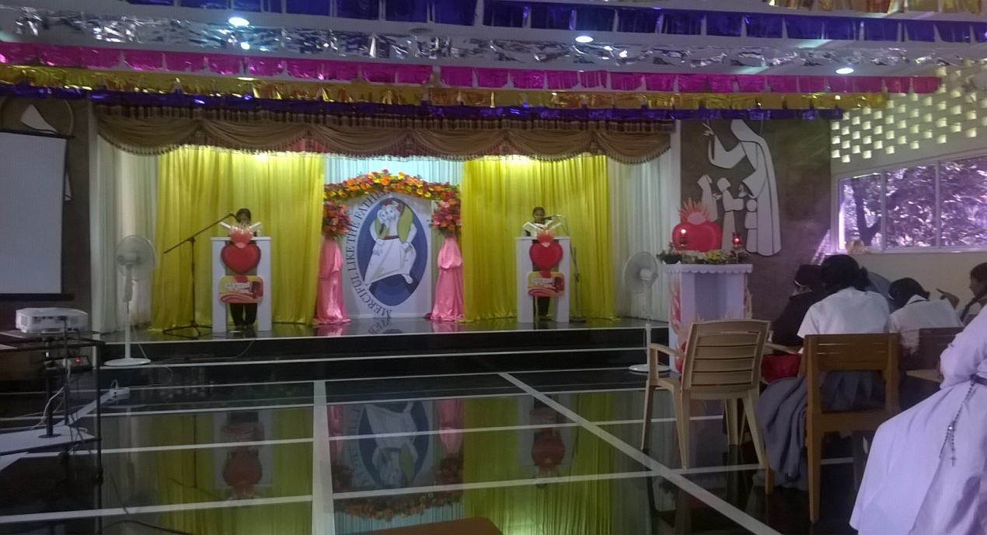
Bible Reading Marathon on 29th December held at POC, Palarivattom.

- Collected used papers from students and donated to “ FIAT” - a mission for printing Holy Bible.

2014-15

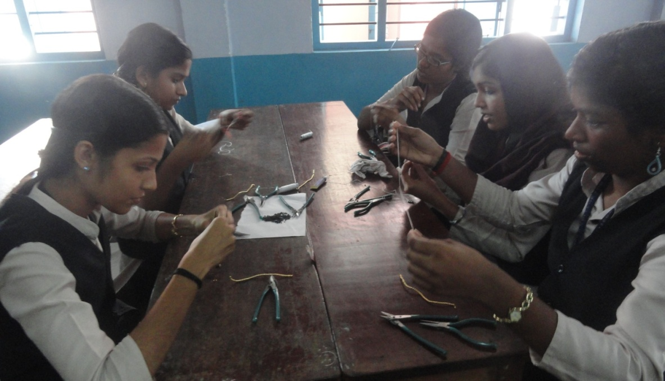
Ornament Making Class

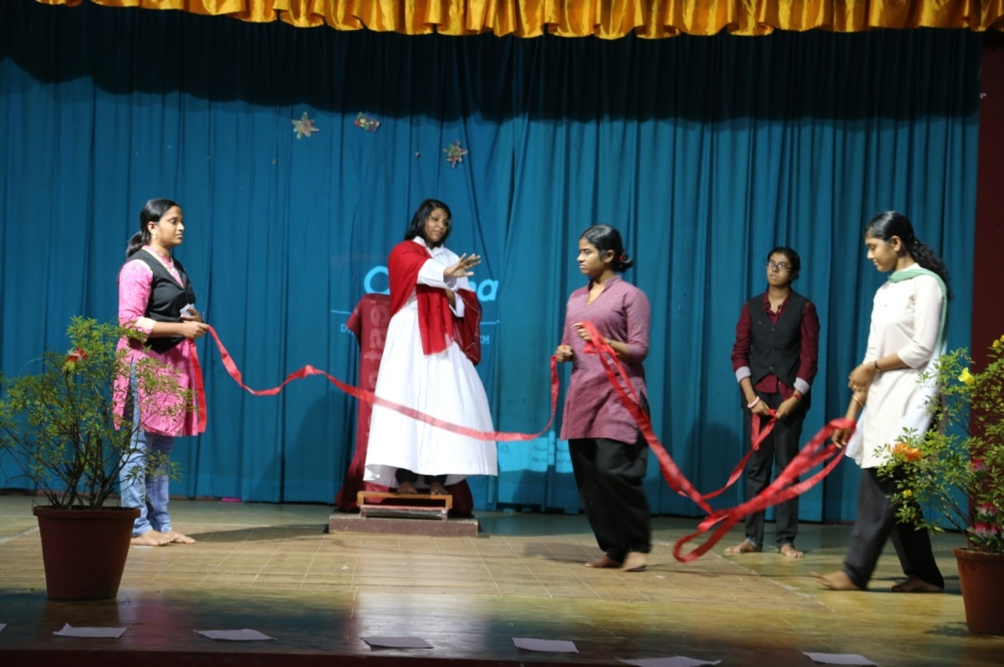

“Ribbons”- Skit by JY
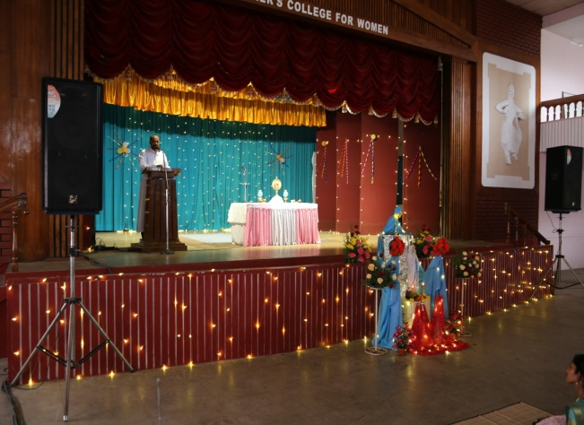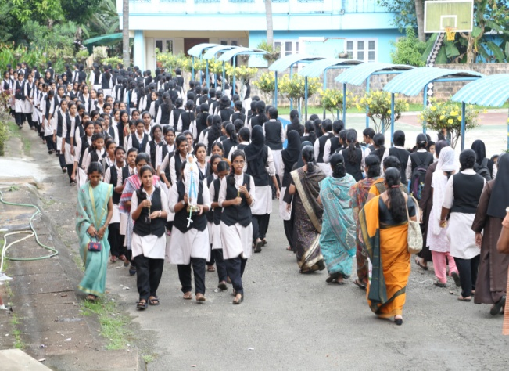
Rosary Month Celebrations

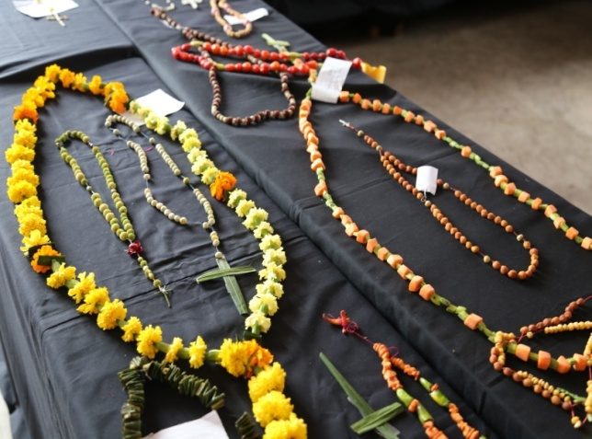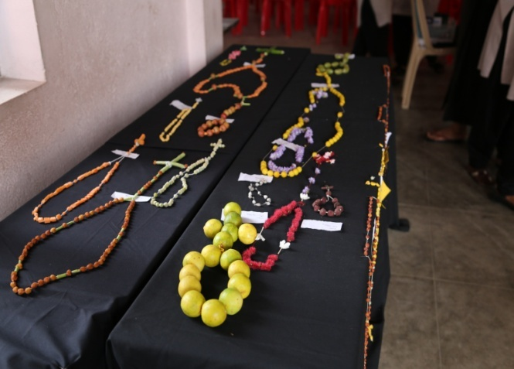
Natural Rosary Exhibition

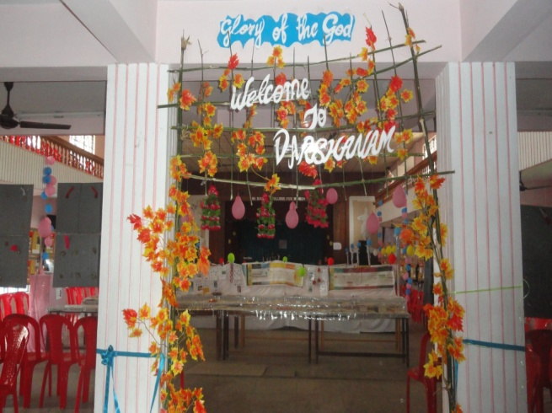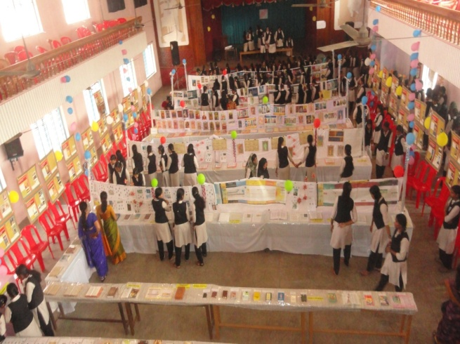

“ Darsanam” – Exhibition of Rosary, Bible and Eucharistic Miracles.

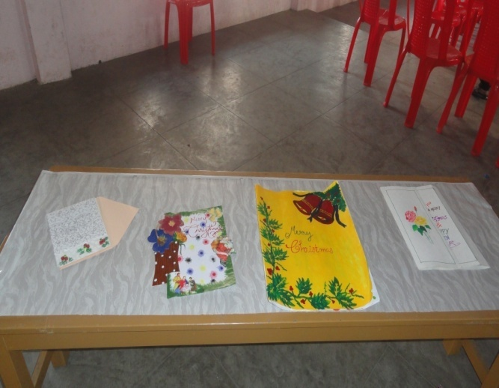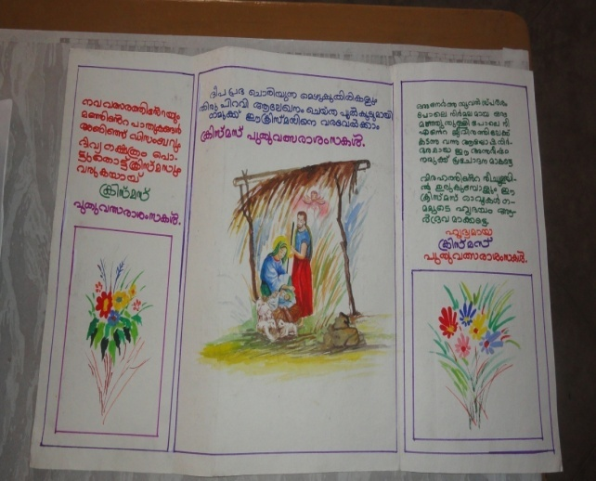
Greeting Card Competition

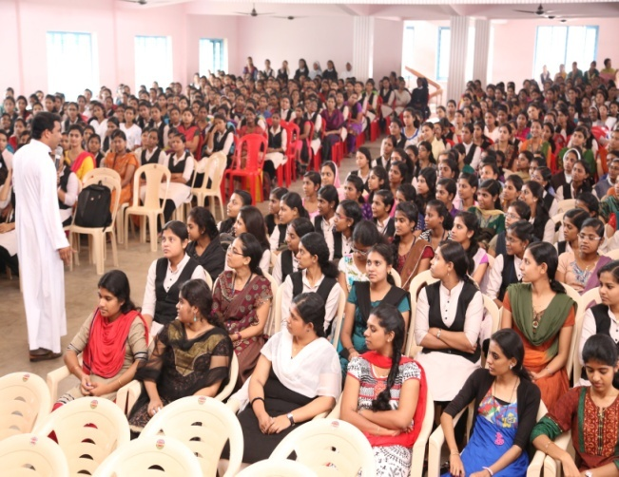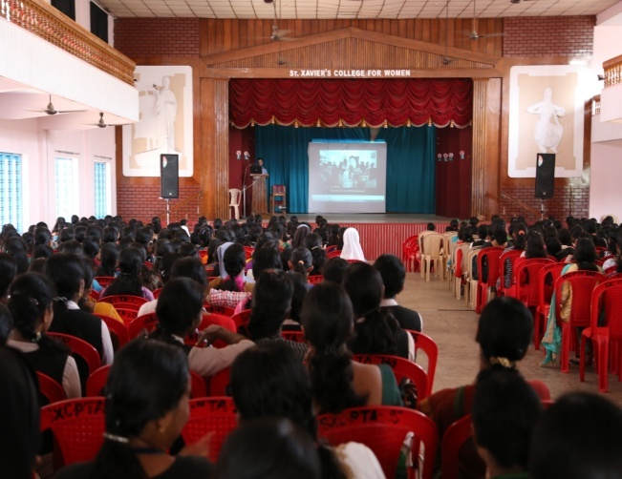
Spiritual Talks by Fr. Biju Mulavarickal and Mr. Sachin Antony

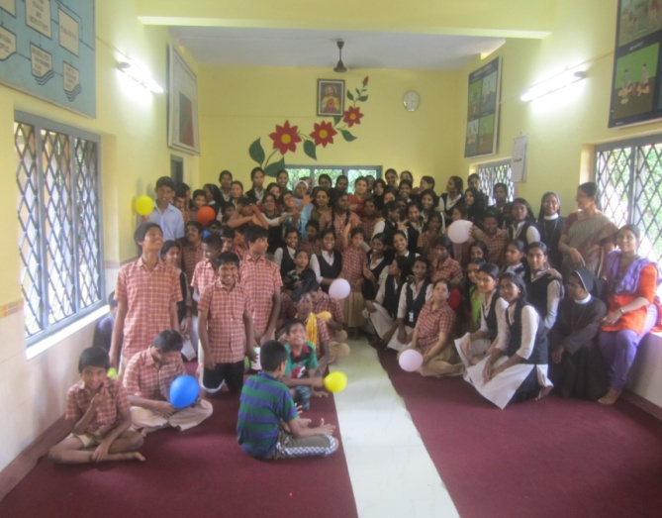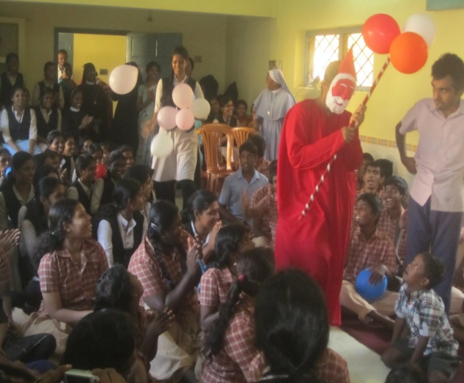
Visit to Karunalayam

2013-14

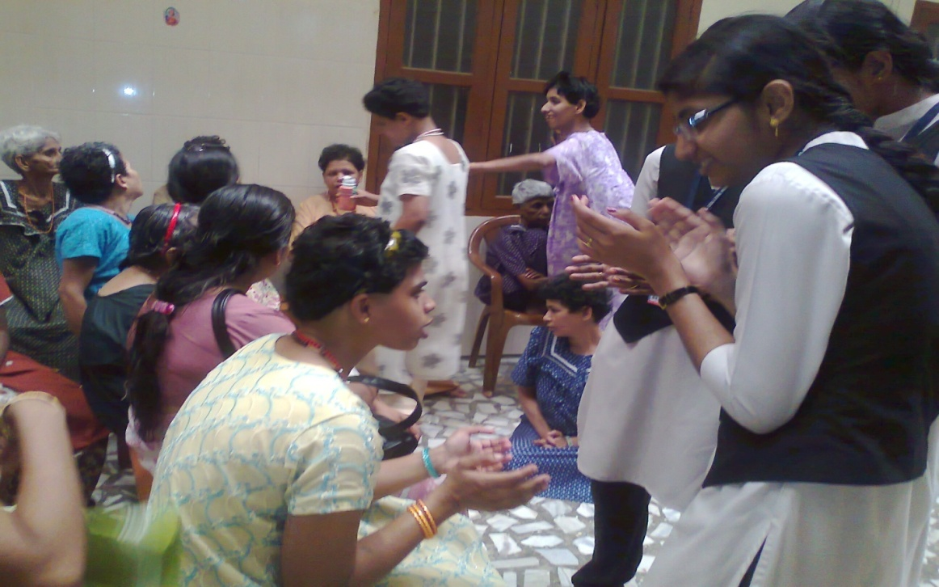

Students at Providence home - a house for the mentally retarded

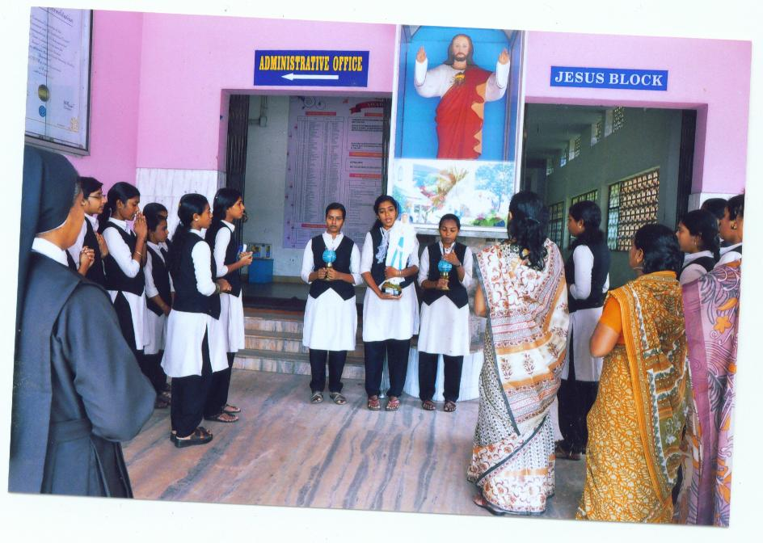
Rosary month Celebration
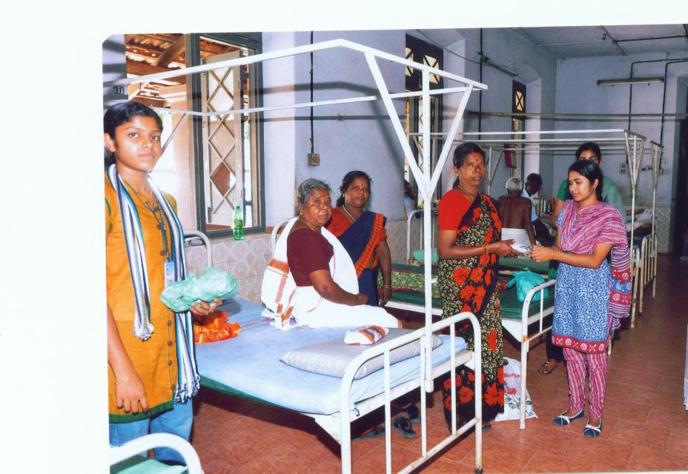

Donating Lunch packets at Govt. Hospital

