NCC (2017-2018)

Our NCC Unit is functioning under the guidance of 7 Kerala Girls Bn, NCC, Thrissur.
- Our cadets senior under Officer Merin Rose and Cpl Salu Paul attended the All India Trekking Expedition at Nilgiris, Ooty.
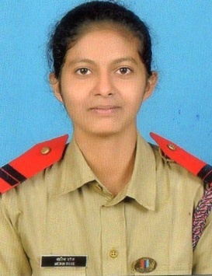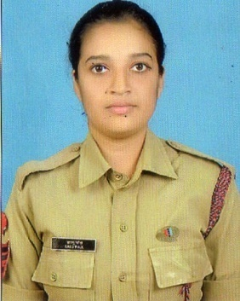
- Cadet Ashmin P James attended the TSC preparatory camp at U.C College, Aluva.
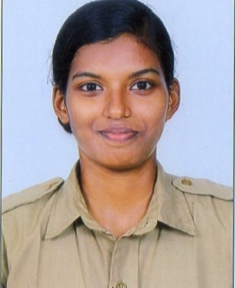
- Cpl Heenu T J, Cadet Arya Mathew, and Cadet Niranjana K S participated the RD preparatory camp at Thiruvillamala.
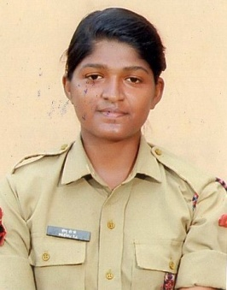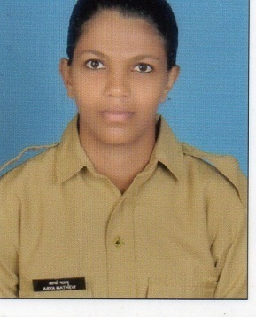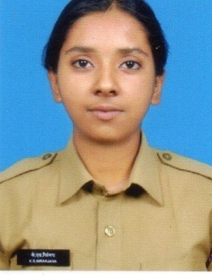
- Our cadet Heenu attended the RD- IGC at Police Academy, Thrissur.
- Yoga Day was celebrated by the cadets on 21st June 2017.
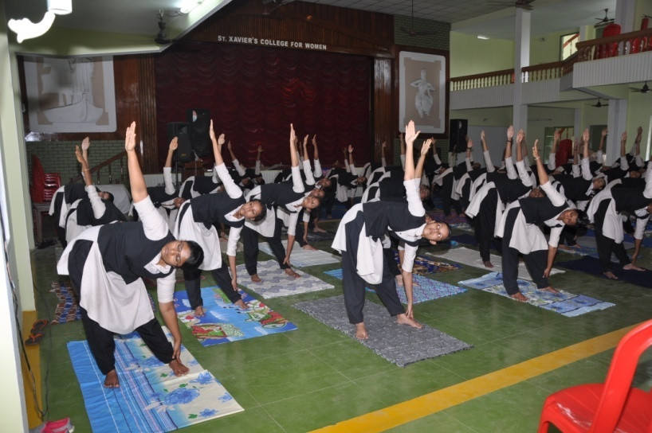

- Guard of Honour was given by our cadets at the time of NAAC Visit. 45 cadets attended the Annual Training camp at Police Academy, Thrissur in September. They bagged the 2nd prize for the line area competition. Cadets won the prizes for sports events.

- Cadets visited the Okhi relief camp at Njarakkal, Vypin and donated Rs.9000/- among the families residing in the Govt School.
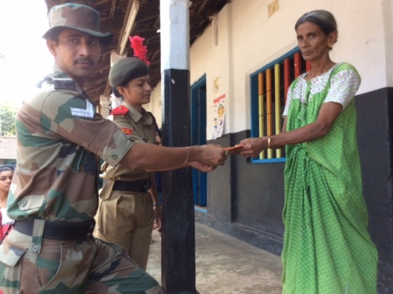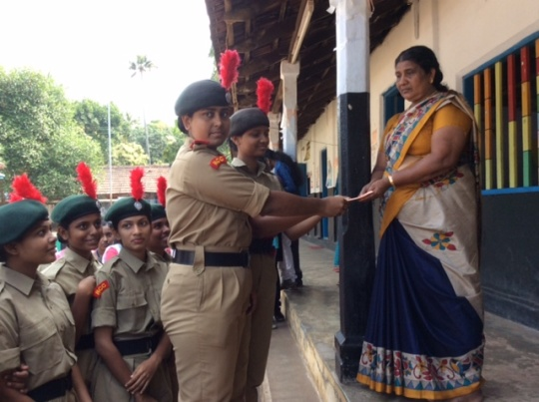

- Blood Donation by the cadets
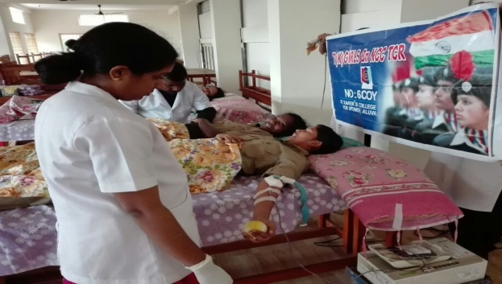

- Cadets attended the class conducted by Aluva SI Usha on traffic rules. Interaction between the students and the police authorities was successfully completed during the class on the topic Stree Suraksha taken by Advocate Mariya.

- The Independence Day and Republic Day was celebrated by the cadets.
