ACTIVITIES
2012-13
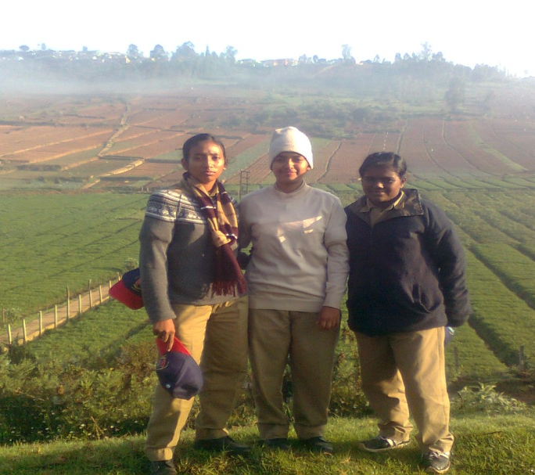
- Our cadets QMSgt Dolly Francis (2nd English lit), CPL Laya Shibu(2nd English lit),L/CPL Rosy Milna(2ND English lit) attended National Trekking camp at Niligiri, Ooty.
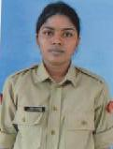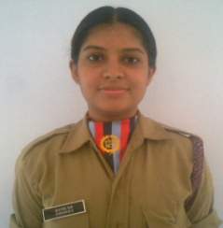
Cdt Surumi Salim Cdt Jayalakshmi Menon
- Our 45 cadets attended annual training camp at UC college Aluva. SUO Meria Meenu Jacob (iii English lit) was the best MC. Cdt Surmi was the best firer and Cdt Jayalakshmi Menon (2ND Zoology) was the Malayali- manga of the said camp.
- 32 Cadets attended the annual training camp at Cheruthuruthi and Peramangalam, Thrissur.
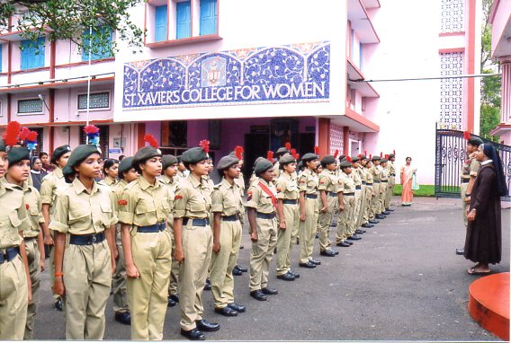
- On Independence Day the flag hosting is done by our principal Rev. Sr. Reethamma the cadets participated in a rally conducted by Aluva municipality.

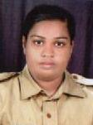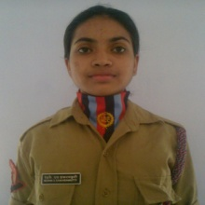
Cdt Jimna Manuel L/CPL Jeeshma P J
- Our cadets Cdt Jimna Manuel (1 Zoology) & L/CPL Jeeshma P J (2ND Microbiology) attended the national integration camp at Kannur and they performed best national integration program during the camp.

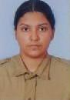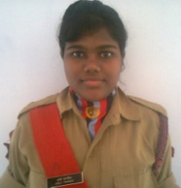
CPL Joelin Joseph Mampilly QMSgt Dolly Francis
- About the pre Thal Sanik camp our cadets QMSgt Dolly Francis (II English) attended Pre TSC 1. CPL Joelin Joseph Mampilly secured 1prize in health and hygiene competition in inter battalion competition

- The cadets of our college conducted trekking at Ezhattumugham

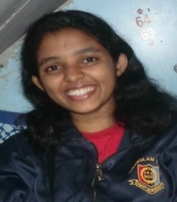
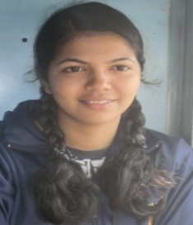
JUO Rosemol Hillariose CPL Mishma Paul
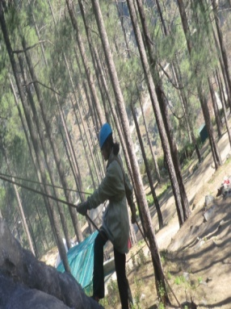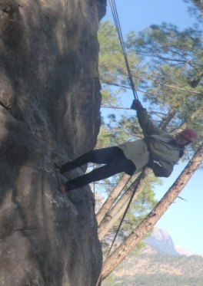
JUO Rosemol Hillariose (2nd English ) & CPL Mishma Paul (2nd Microbiology) attended the mountaineering camp at Uttarkashi in December 2012 at minus degree temperature. They bagged many prizes. In bewoking competition (tent making) CPL and obstacle race competition Mishma Paul came first she also got 2nd in wall climbing. JUO Rosemol Hillariose secured the following prizes. Bewoking competition - 3rd cross country - 2nd point to point march- 2nd They are the two cadets from south India participated the above mentioned mountaineering camp.

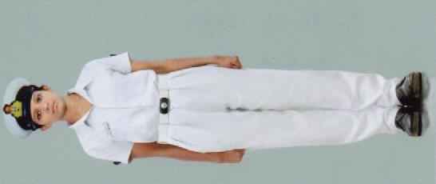
- Emilda P Raju of 3rd DC Economics is the first naval cadet of our college. She has completed her training as a naval cadet from St. Albert college, Ernakulam. She got the ‘B’ certificate and passed the ‘C’ certificate in the year 2013. She attended the annual training camp at Kanjiramattom, Panangad and all India annual training camp at Kozikode.

- On December 7th 2012 all cadets of our college visited Naval Base Kochi during the naval week. Awareness class about weapon is obtained. Ship visiting and aircraft visiting has been done by our cadets.

2013-2014
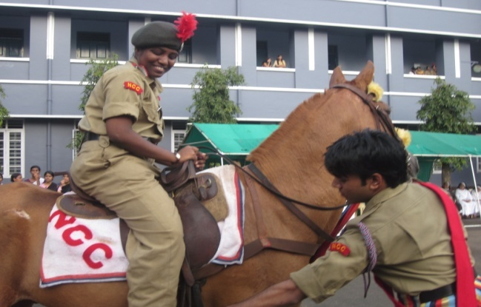
- Horse riding by SUO Reshma KS during the ATC camp.
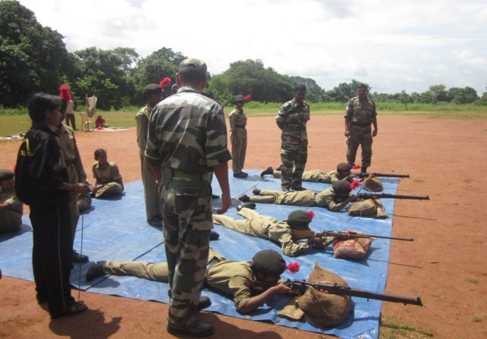
- Firing practice during the ATC camp.
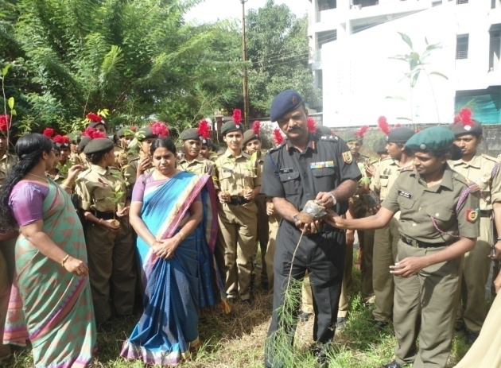
- Tree Plantation during the camp.

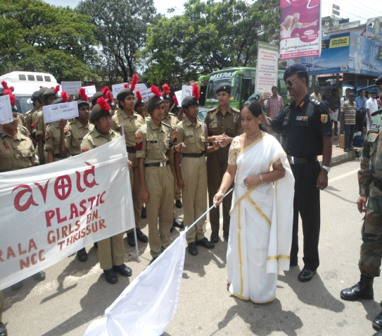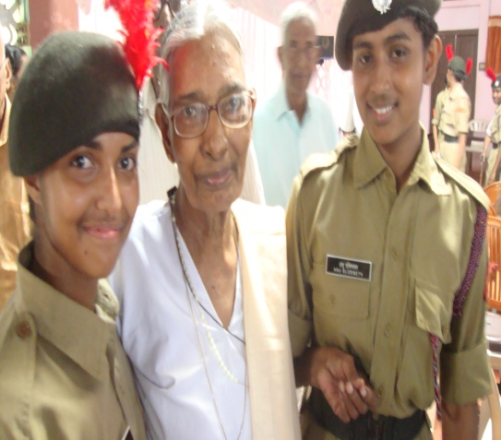

- Annual Training camp at Vimala College Thrissur - 13/09/13 to 22/09/2013 62 cadets participated. During the camp cadets participated in blood donation, Anti-plastic rally and visited old age home.

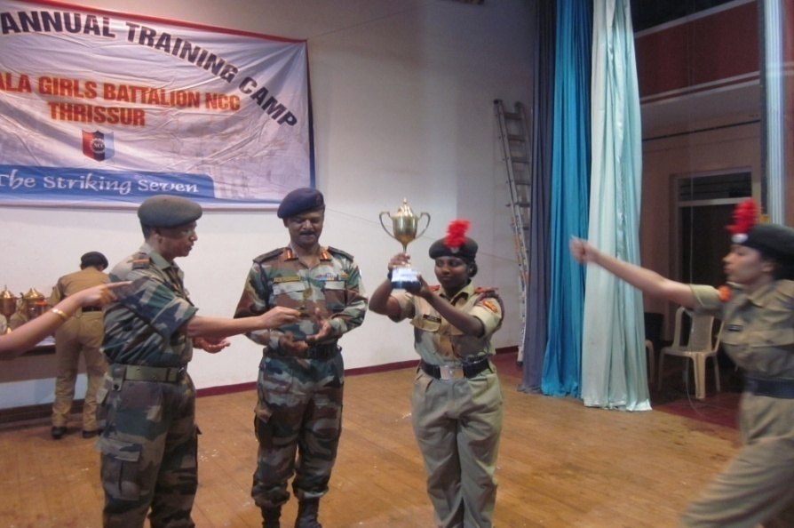
- SUO Reshma K S Won first prize for best individual drill during the ATC camp at Vimala College, Thrissur- 13/09/2013 to 22/09/2013.
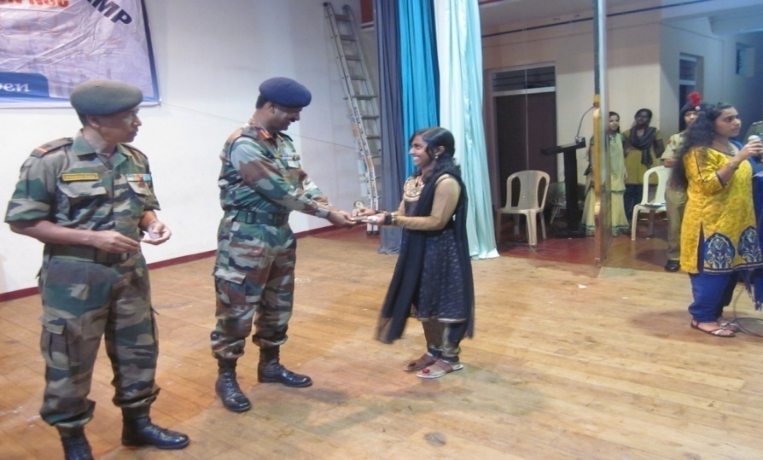
- Sneha Jose- Best Master of ceremony during the ATC at Vimala College -13/09/2013 to 22/09/2013.

- Our College won second prize for line area competition during the ATC at Vimala College -13/09/2013 to 22/09/2013.
- 5 cadets attended the pre-Tal Sainik camp held at MES College, Marampally. Sneha Jos won the best cadet award during the camp-20/12/2013 to 30/12/2013.
- 2 cadets attended the pre-RD Training Camp at Padoor- 21/12/13.

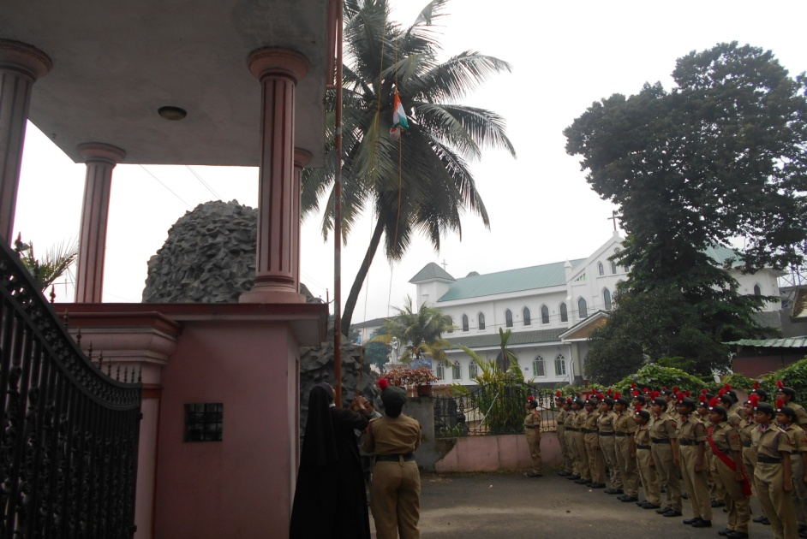
- Flag hoisting by our Principal Rev.Sr.Reethamma on 15/08/13 and 26/01/14.
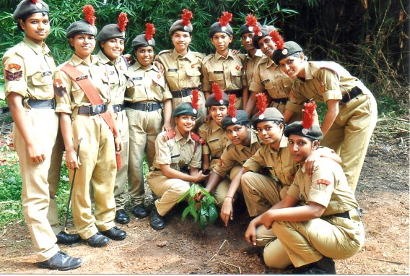
- Tree Plantation by the cadets

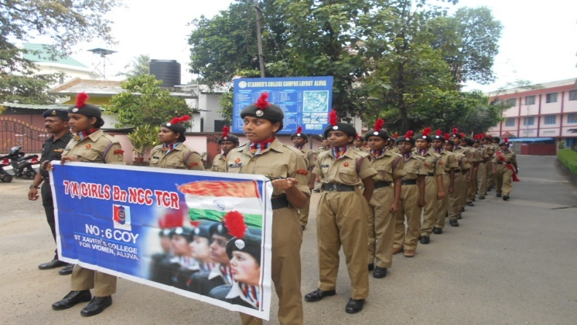
- Conducted Aids day rally- 1/12/13.

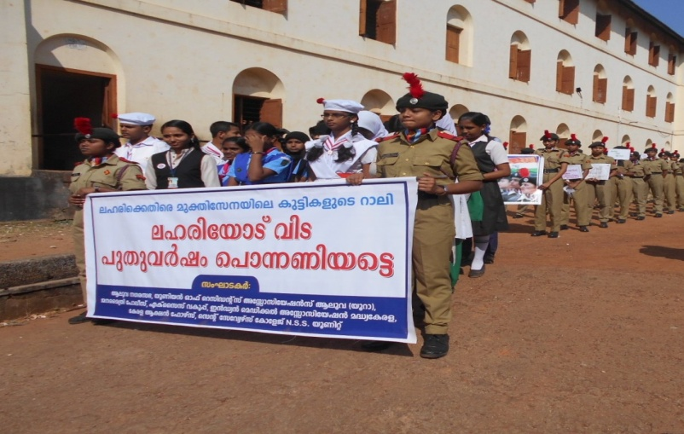
- Anti-drug campaign rally- 30/12/13.
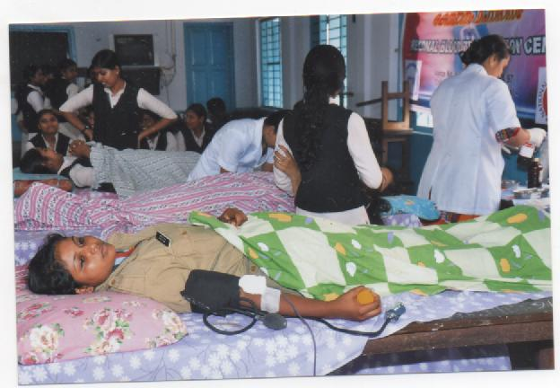
- Cadets participated in the blood donation camp-01/10/13.

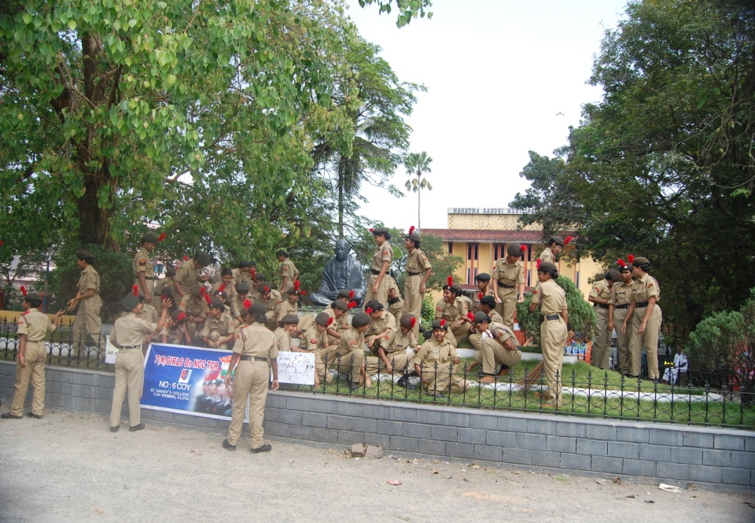
- Cleaning by the cadets in the Town hall premises.
- Piloting the honorable Ex- President of India Dr.A.P.J Abdul Kalam- 26/12/13.

2014-2015
April and May-
- SS College, Kalady- 4 cadets selected for TSC preparatory classes and training.
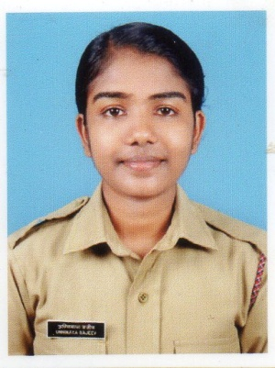 Sgt Maj Unnimaya Sajeev
- UC College -1cadet was selected( Sgt Maj Unnimaya Sajeev)for pre-TSC
June-
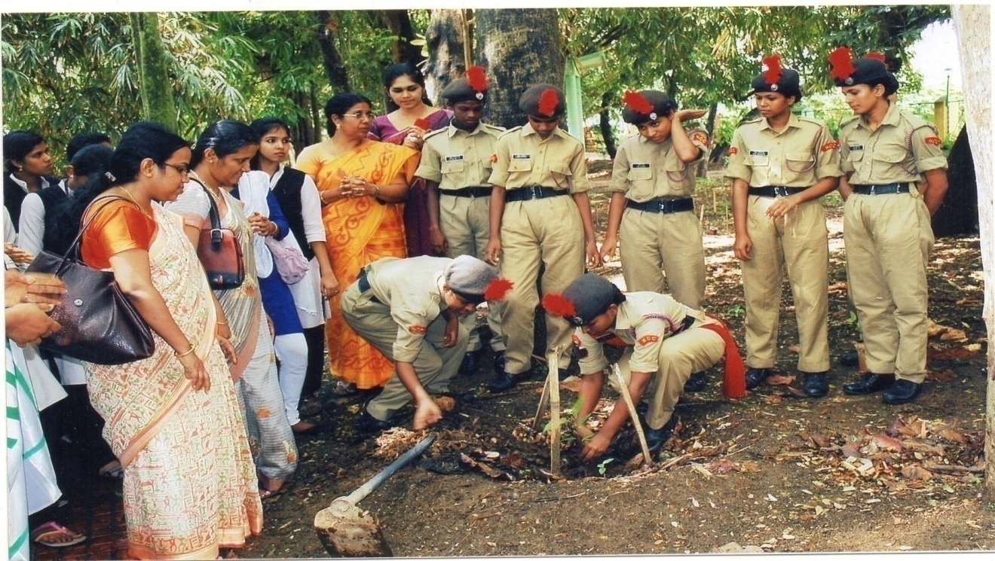
- On Environment day cadets planted saplings at Harithavanam.

August-
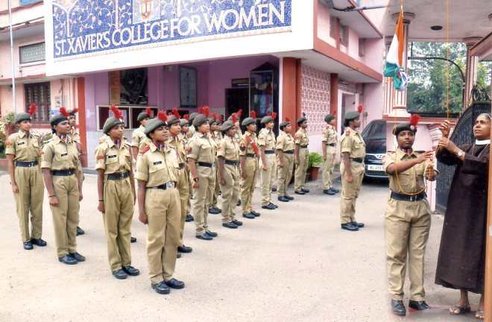
- Independence Day was celebrated with flag hoisting and parade.

September-
- Our cadets took part in the ATC camp conducted at S.C.A.M Govt College, Kuttenellur, from 5th to 14th Sep. Our College took the runner’s –up trophy.

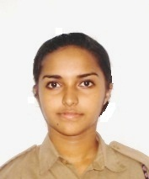
- SUO. Sneha Jos was awarded as the Best Cadet and won the 1st prize for individual drill completion. We were also winners of tug of war and other extracurricular activities. SUO was the company senior of the camp.

October-
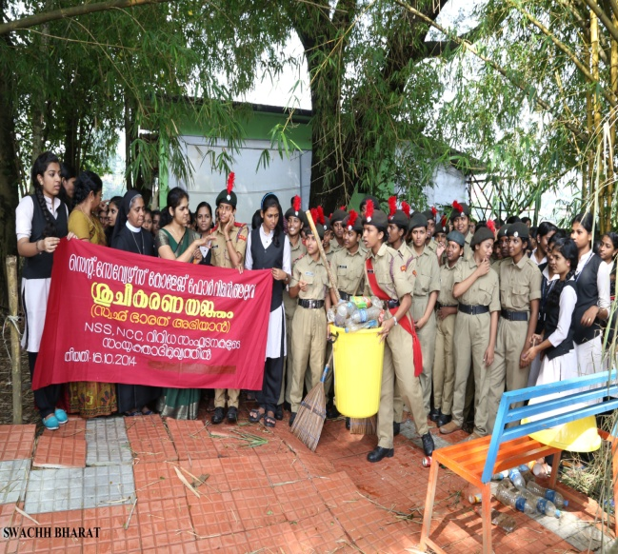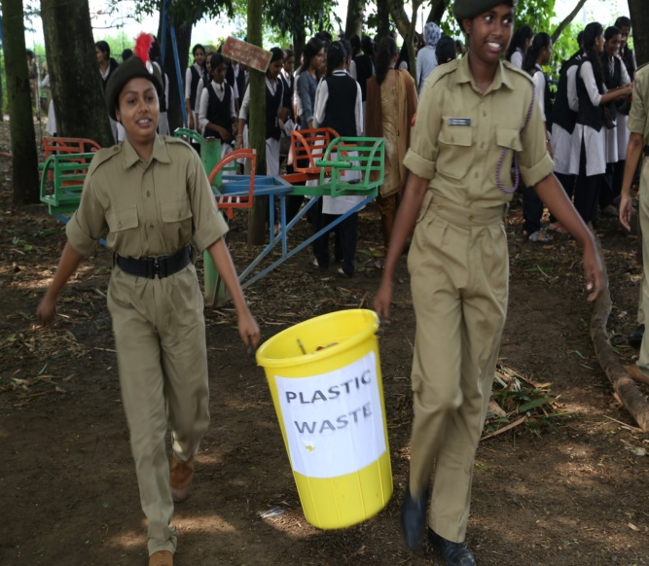
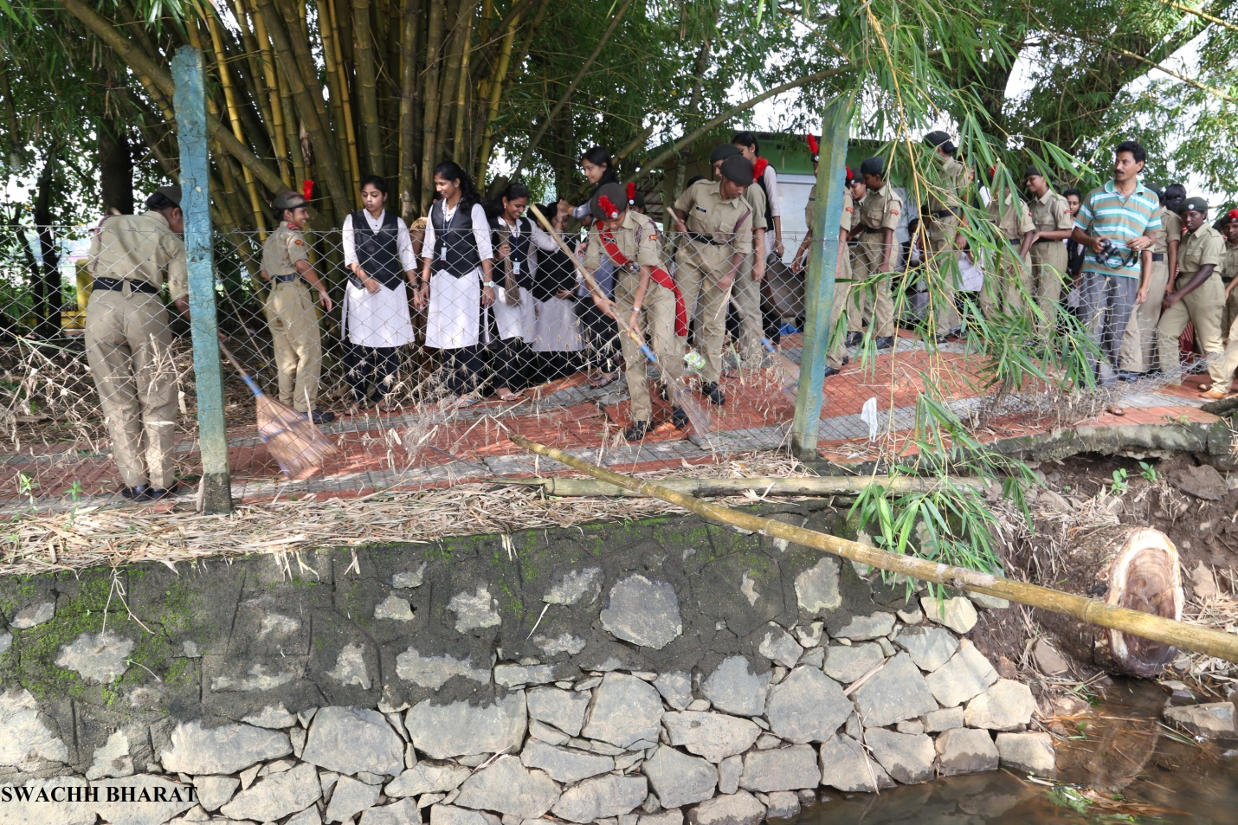
- Cadets actively participated in “ Swach Bharat Movement” at Manapuram on 16th.
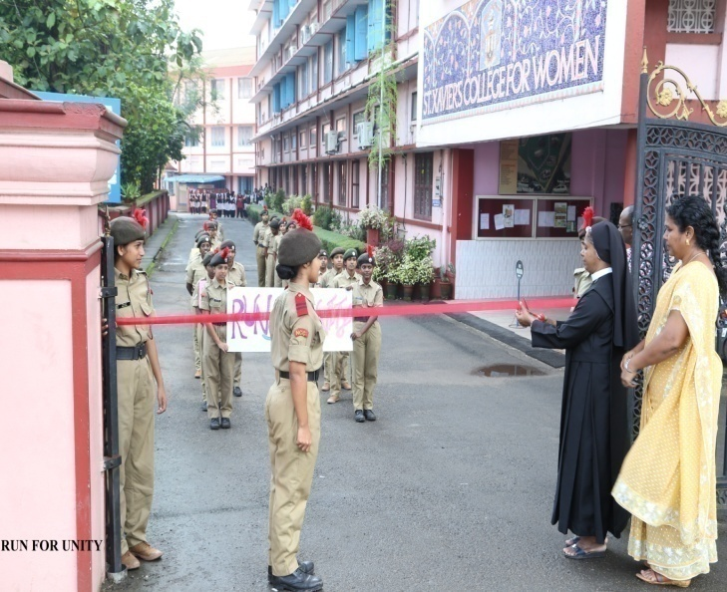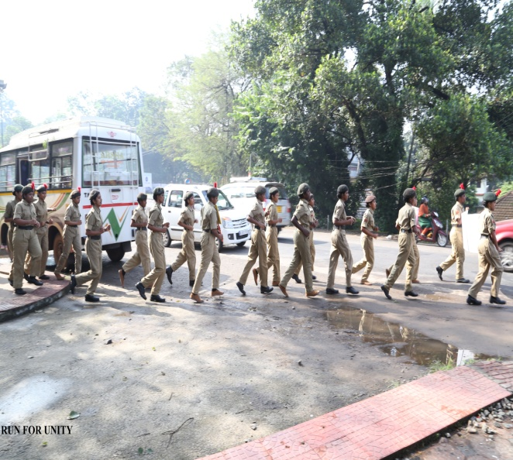
- As a part of “Unity Day” a “Run for Unity” was conducted commemorating Birthday of Sardar Vallabhai Patel on 31st. It was inaugurated and the flag off was done by the Principal.
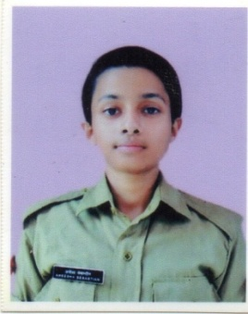
- JUO Aneena Thomas attended IGC camp.
November-
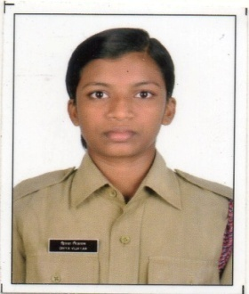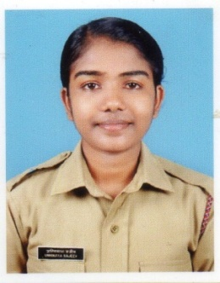
- Two cadets of our college CQMS. Divya Vijayan and Sgt.Maj. Unnimaya Sajeev were selected to attend All India Girls trekking Expedition atAjmeer, Rajasthan. From 1st- 14th Nov.
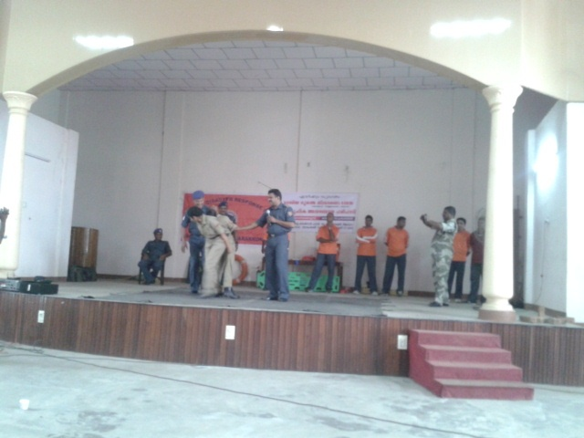
- Cadets took part in the disaster Management classes organized at UC College, Aluva, by NDRF 4BN, Arakonam on 27th.

December-
- On Aids Day cadets by organized rally.
January-
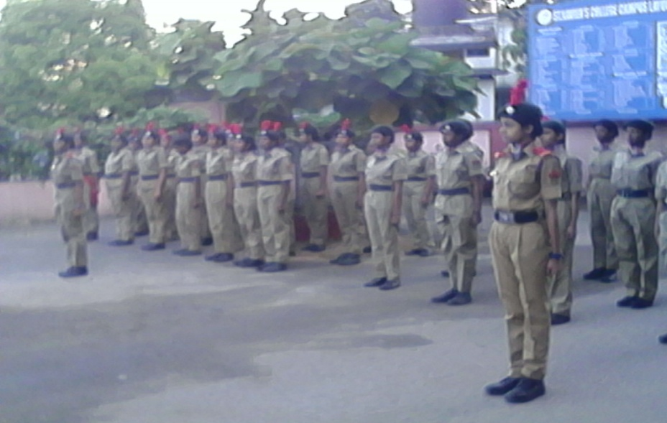
- Celebrated Republic Day by flag hoisting followed by the parade.
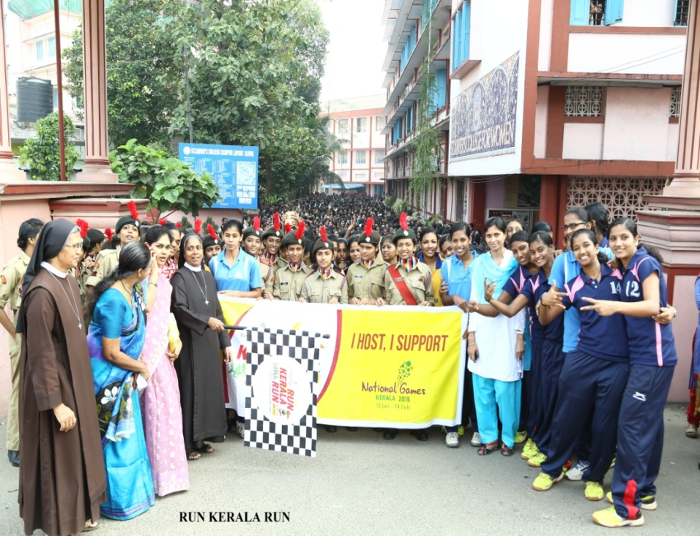
- As a part of 35th National Games, we took part in the “Run Kerala Run” campaign on 20th. A run was arranged from post office junction to Nehru park.

February-
- 10 cadets selected as National Games Volunteers 2015 and they were appointed in various centers of Ernakulam District.

2015-2016
June-
- Planted saplings on Environment Day

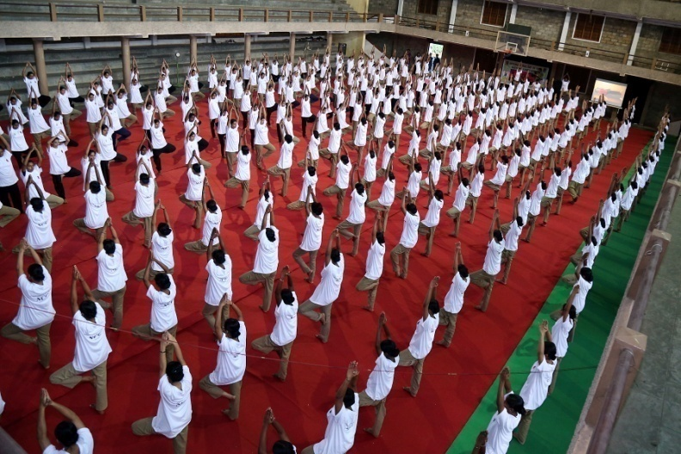
- 54 cadets participated in the International Yoga day declared by the Prime Minister at St.Joseph College, Irinjalakkuda.

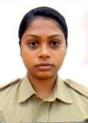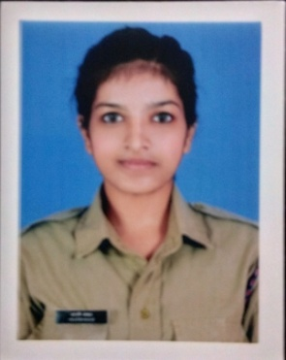
- Midhula and Arathi Anjat attended TSC-preparatory camp at and U. C college, Aluva

August-
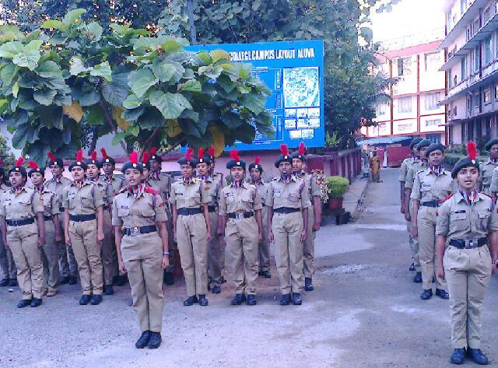
- Celebrated Independence Day.

September-
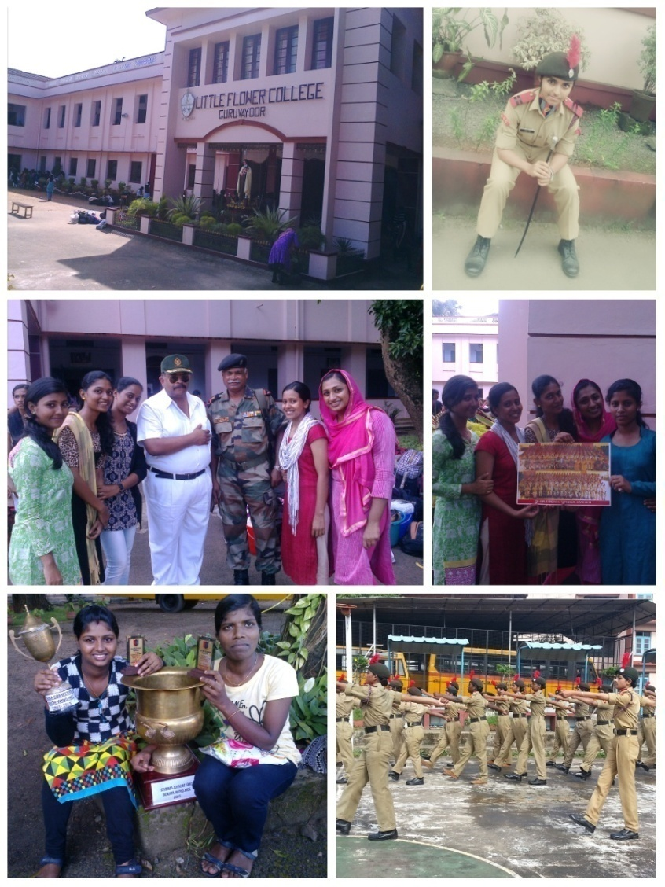
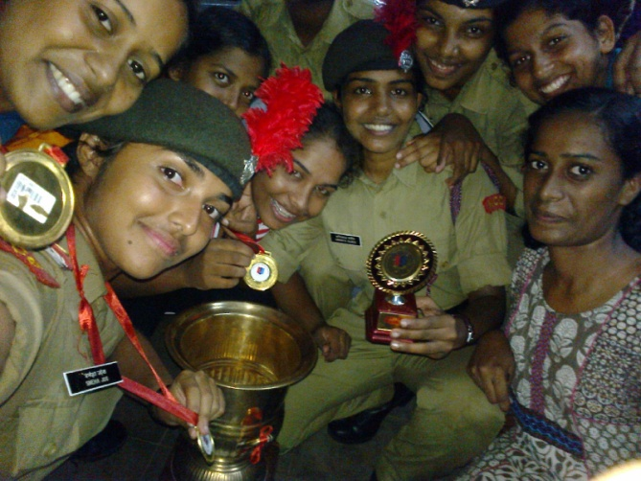
- 62 Cadets attended the annual training camp at LF College, Guruvayoor. During the camp our college won the overall championship.

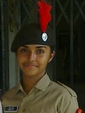
- SUO Sneha Jos selected as the best cadet in ATC Camp.

October-
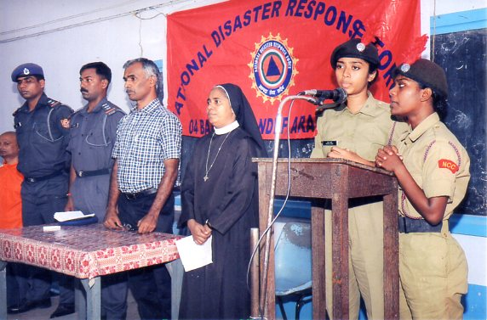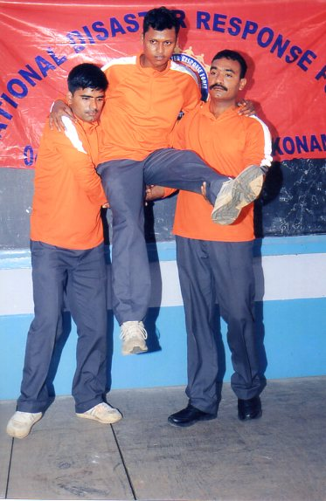
- Our cadets attended the class on the Disaster management by 4(Bn) NDRC Arakkonam.

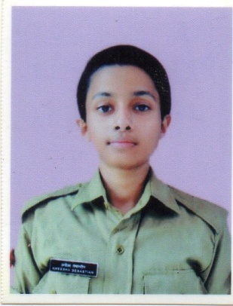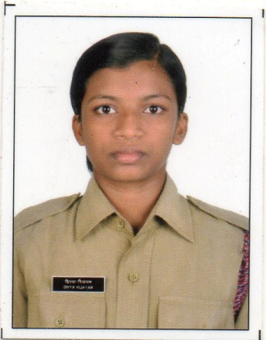
- Aneena Thomas, Amitha Vasu , Divya Vijayan, Reshma Satheesh attended the annual training camp at Police academy.

November-
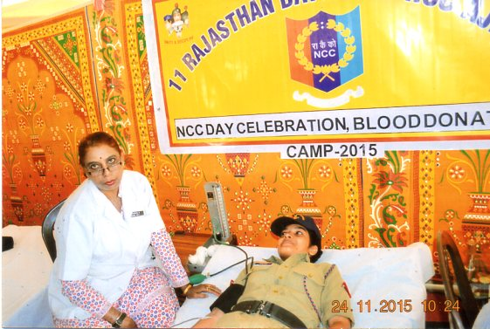
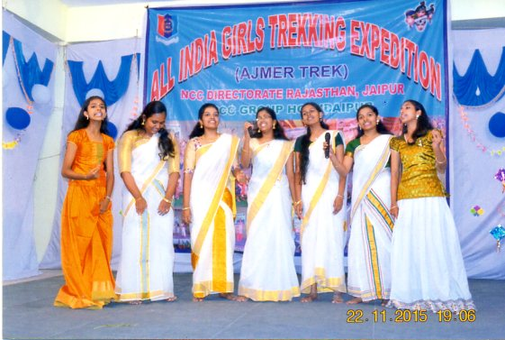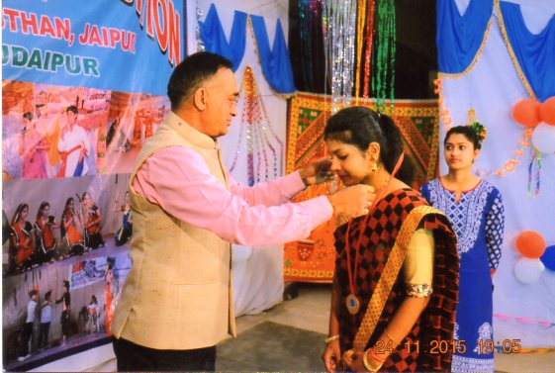
- Our Cadet Arathi Anjat attended all India trekking camp at Ajmer, Rajasthan and won gold medal for Master of Ceremony, group dance and silver medal for group song.

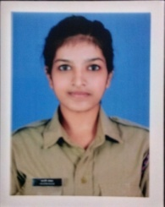
- L/Cpl.Arathi Anjat selected for the ‘best cadet scholarship’ in the unit level.
December-
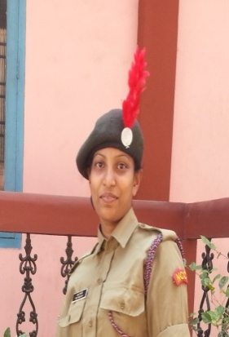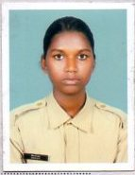
- Anu Augusty, Anagha P Parthan attended NCC National Games Launching Camp at St.Joseph College, Moolamattam ( Idukki)

January-
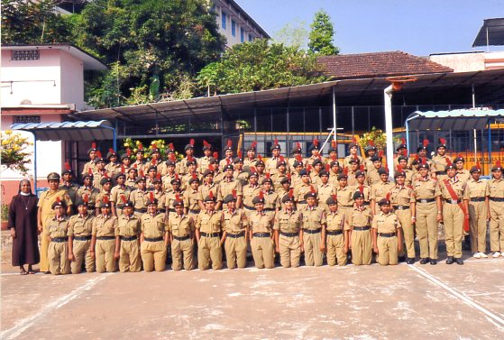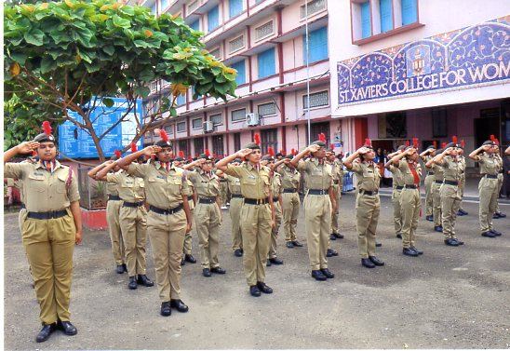
- Celebrated the Republic Day

