REPORT OF ACTIVITIES OF RESEARCH PROMOTION COUNCIL 2017-18

- 16-member committee with Principal as the chairperson, Co ordinator- Dr. Anu Anto; Secretary- Dr. Liss Marie Das & faculty representatives from each department and a student representative.

- The inauguration of activities of this academic year (2017-18) was done on 09-06-17 by Dr. Ajay Sekhar, Associate Professor in English, Sree Sankara University of Sanskrit, Kalady. He delivered a talk on “Philosophical Speculations on Knowledge”.

- The Book of Abstracts of paper presentations that was conducted in 2016-17 were released on the same day.

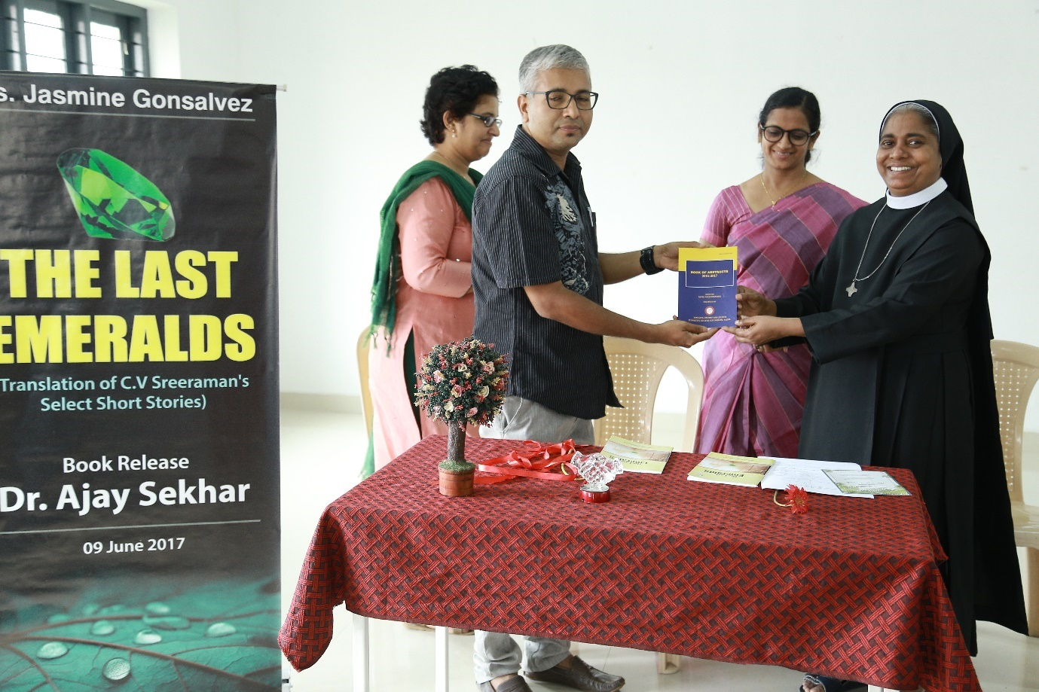

- The release of The Last Emeralds (a book translated from Malayalam) by Ms. Jasmine Gonsalvez, Department of English of our college were also released on the inaugural day.

- Dr. Deepthi Menon, Professor at the Amrita Centre for Nanosciences & Molecular Medicine, Amrita Vishwa Vidyapeethaminteracted with the students in a program titled Coffee with a scientist on August 14th, 2017. This was organized under the auspices of Research Promotion Council of the College by Departments of Mathematics and Statistics. 15 students interacted with the scientist.
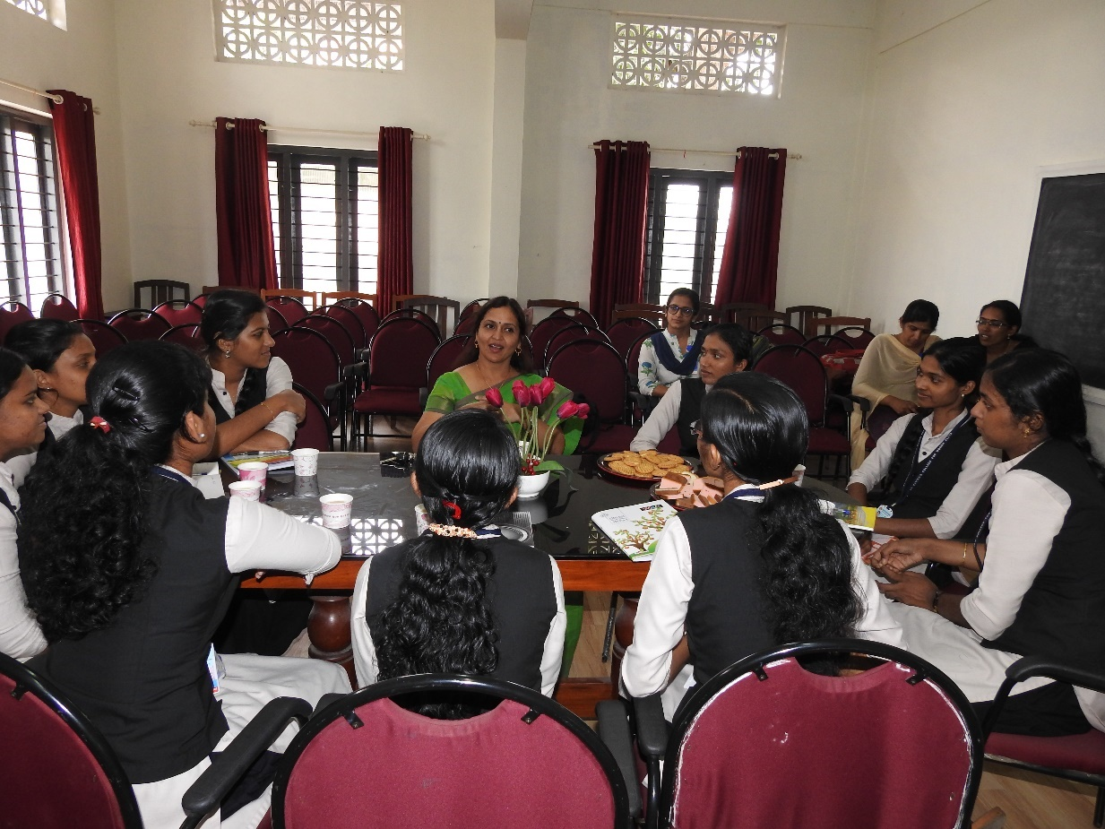
- Organized Campus Bird Count, in association with Department of Zoology from Feb 16-19, 2018. This is a sub event of Greater Backyard Bird Count (GBBC) organized by Citizen scientists across the world. 25 species were uploaded to ebird.org,citizen science website.
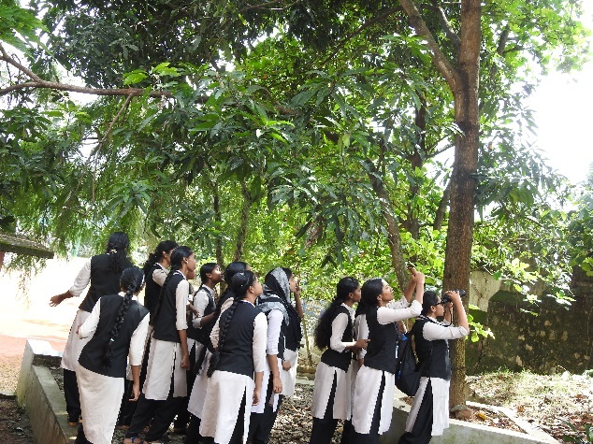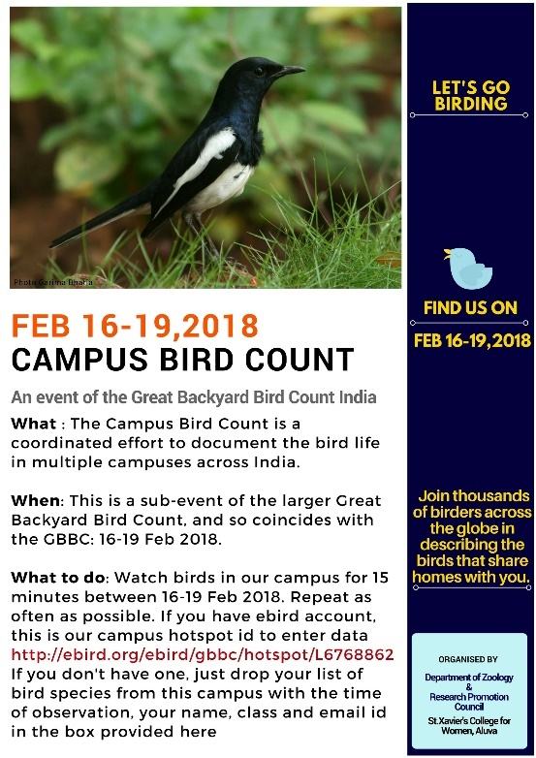

- Talk by Dr. Asha M.S., Professor, Department of Physics, CUSAT on Current Trends in Thin Film Technology on March 9, 2018

- Five paper presentation sessions were conducted- 14 papers both by faculty and students were presented during these sessions.

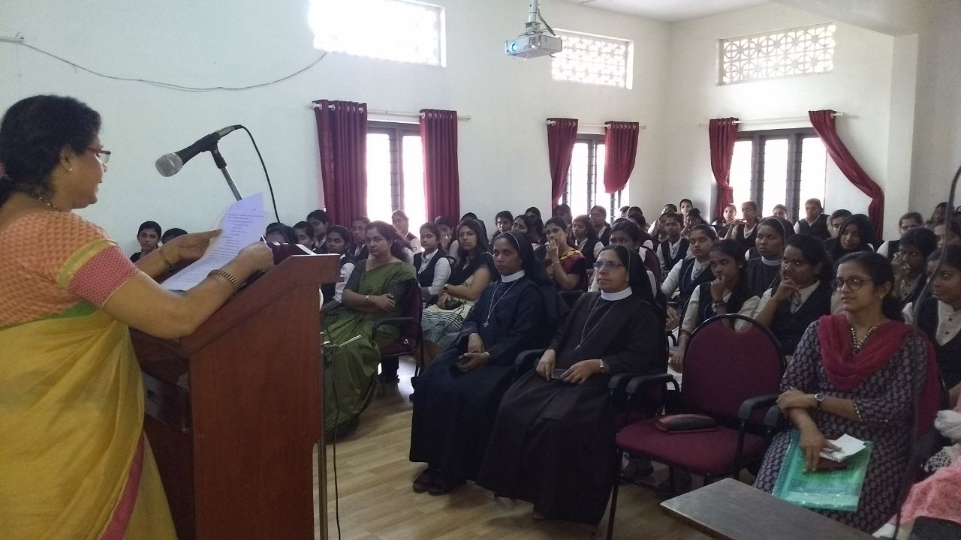

- Two issues of Peer reviewed multidisciplinary journal- DISCOURSE (ISSN 2321-0214) were published

- Journal has applied for its inclusion in the M.G. University approved journals

- Athira Venugopal of 3rd year B.Sc. Botany was awarded as the Best Paper Presenter of the Monthly Paper Presentation series held during 2016-17. 