2013-14
- Activities of the Research Promotion Council for the year 2013-14 were inaugurated by Rev. Dr. Sr. Benedicta, Vice Principal, St.Xavier’s College for Women, Aluva on 14th June 2013.
- RPC in association with Department of Microbiology organized a one day seminar on “Intellectual Property Rights” sponsored by Patent Information Centre, KSCSTE on 23rd January, 2014. Seminar was inaugurated by Bhadra B, Deputy Mayor, Cochin Corporation
- Monthly Paper Presentation Sessions were conducted on every second Fridays. Nine paper presentation sessions were conducted during the academic year.
- 32 research papers both by the faculty and by the students were presented during these sessions
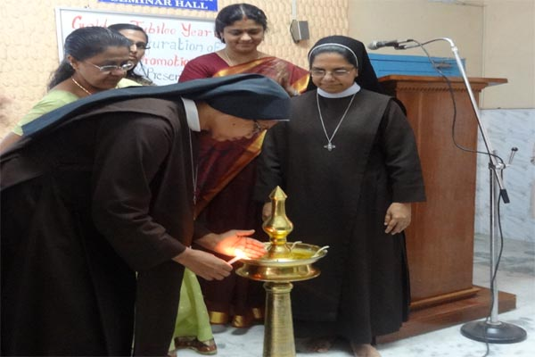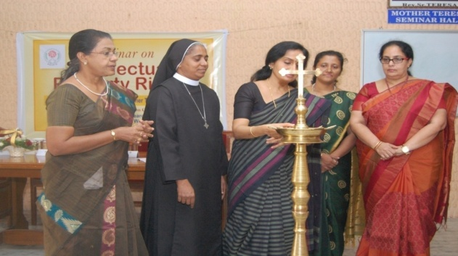
Inauguration of activities Inauguration of seminar on “Intellectual Property Rights”
2014-15
- Activities of the Research Promotion Council for the year 2014-15 were inaugurated by Dr. A. Vijayakumar, Department of Mathematics, CUSAT on June 13, 2014. Delivered a lecture on “Use of Metrics in evaluating research”.
- Dr. Sabu T. Program Director, Centre for Environment and Development delivered a talk on “How to write effective research proposals” on 24th July 2014.
- Research Promotion Council associated with Department of Zoology in conducting popular lecture on the theme “Ozone Layer Protection: The Mission Goes On” sponsored by KSCSTE on 26th September 2014.
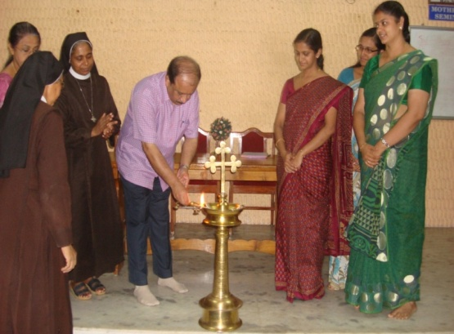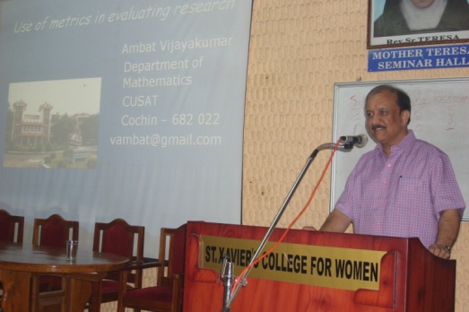
Inauguration of activities and lecture
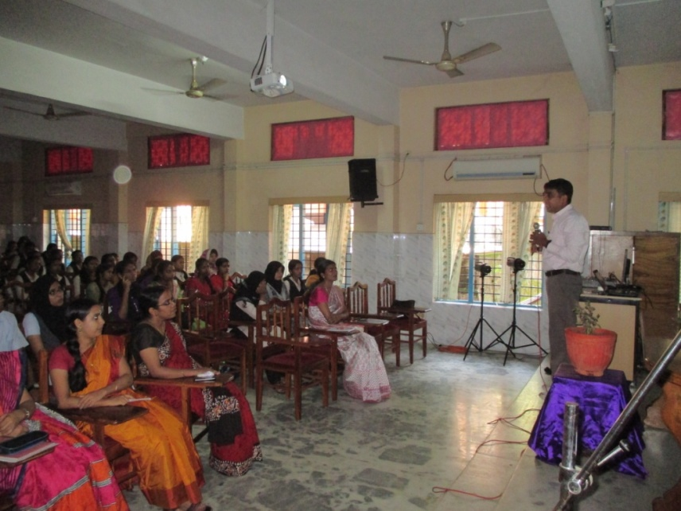
Dr A.A. Mohammed Hatha, Head, Department of Marine Biology, Microbiology and Biochemistry, CUSAT on Ozone day observation
- Monthly Paper Presentation Sessions were conducted on every second Fridays. Nine paper presentation sessions were conducted during this academic year. 30 research papers both by the faculty and by the students were presented during these sessions.
- A book of abstracts was published based on the paper presentations made during this session
2015-16
- Activities for the year 2015-16 were inaugurated by eminent academician Dr. Shaju Thomas, Head of the Department, P.G. Department of Zoology, Nirmala College Muvattupuzha on 19th June 2015. Delivered a lecture on “Research in higher Education- Where we stand”.
- 9 paper presentation sessions were conducted during this academic year. 28 research papers both by the faculty and by the students were presented during these sessions.
- A book of abstracts was published based on the paper presentations made during this session

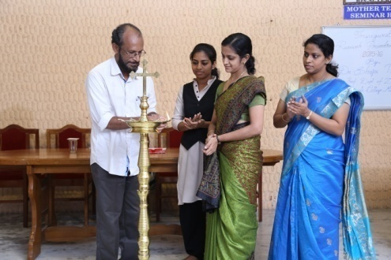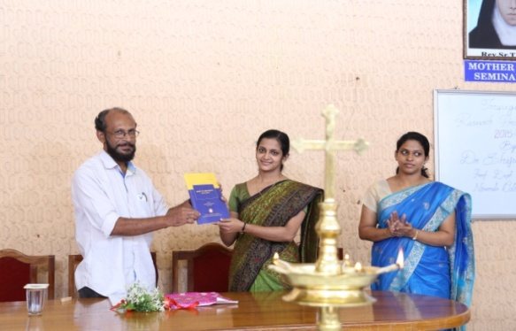
Inauguration of activities and release of book of abstracts
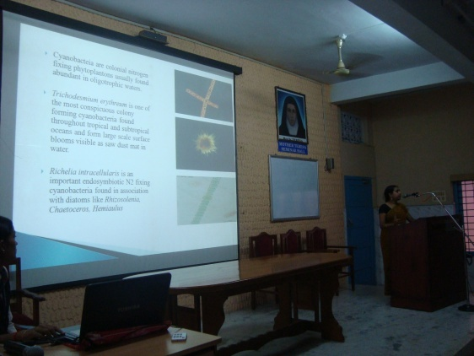
A paper presentation session in progress
2016-17
- 2016-17 activities of RPC was inaugurated by Dr. Gigi K. Joseph, Assistant Professor Department of Zoology, Nirmala College Muvattupuzha held at Mother Teresa Seminar hall on 14th June 2016.
- The chief guest delivered a talk on the topic “Why go wild?- Importance of Wild life Conservation”. Inaugural function was funded by KSCSTE as part of World Environmental Day Celebrations 2016.
- Intercollegiate Competitions on painting and essay writing based on the focal theme of WED were held on 8th June 2016- sponsored by KSCSTE
- 15 students are actively participating in citizen science projects

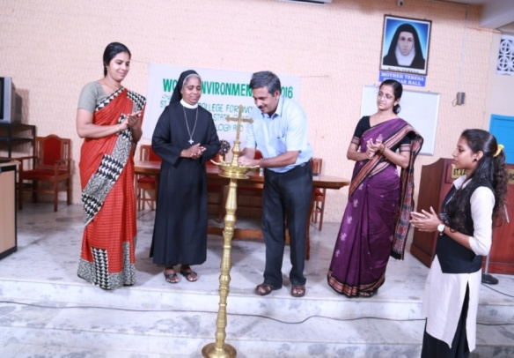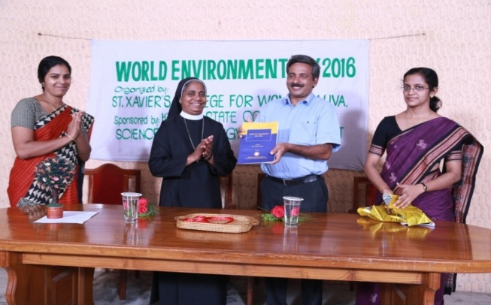
Inauguration of activities and relesase of Book of Abstracts 2015-16 by Dr. Gigi K. Joseph
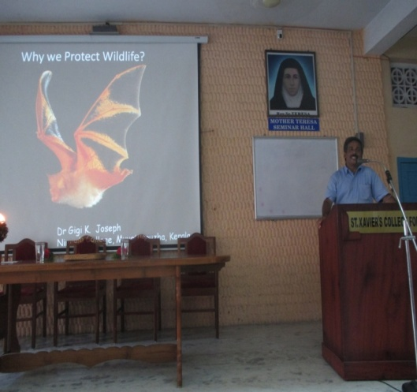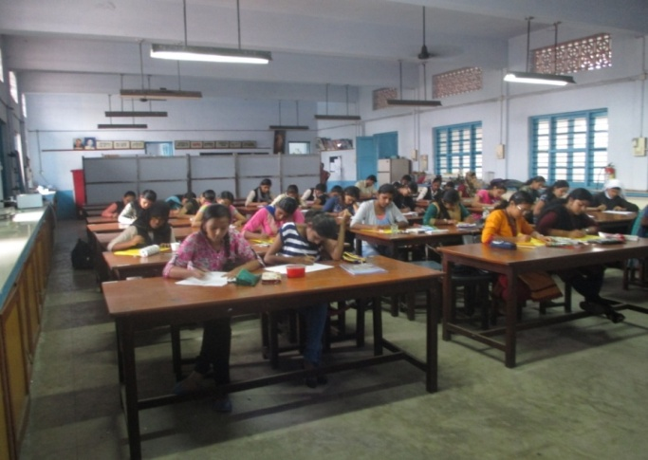
Talk by Dr. Gigi K Joseph Painting competition on WED 2016
- A talk on NMR Spectroscopy by Dr. Cyriac Mathew, Associate Professor (Rtd.) St. Albert’s College, Ernakulam on 12th August 2016
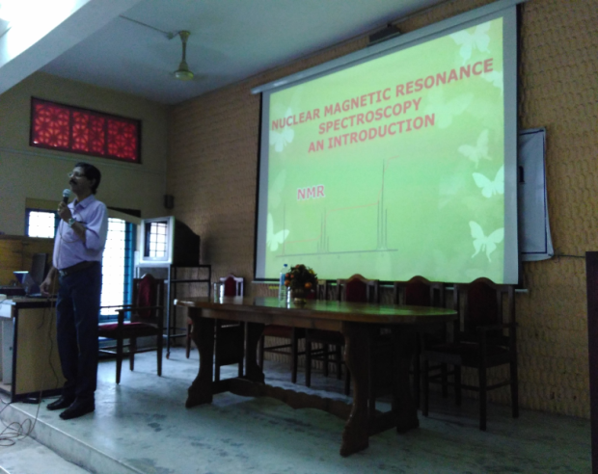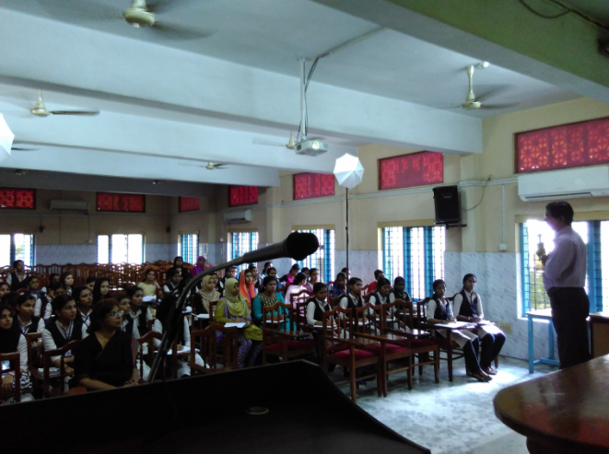

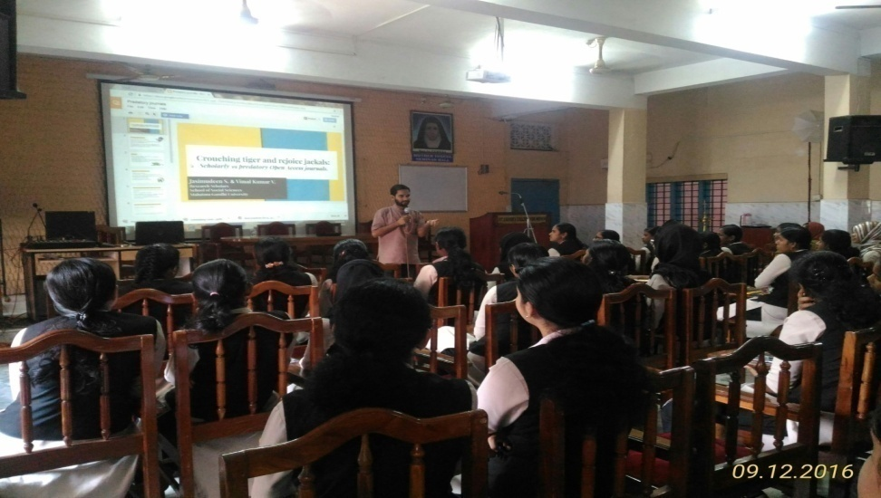
Talk on “Demystifying Academic Plagiarism” by Mr. Jasumudheen, Librarian, St. Stephen’s College, Uzhavoor on 9th December 2016

