REPORT OF ACTIVITIES OF RESEARCH PROMOTION COUNCIL 2018-19

- The inauguration of activities of this academic year (2018-19) was done on 08-06-18 by Dr. Sangeetha Mohan, Senior Scientist, Sci Genome Labs (Pvt. Ltd.) Kakkanad. She delivered a talk on “Challenges and opportunities in Higher Education and Research”.

- The Book of Abstracts of paper presentations that was conducted in 2017-18 were released on the same day.

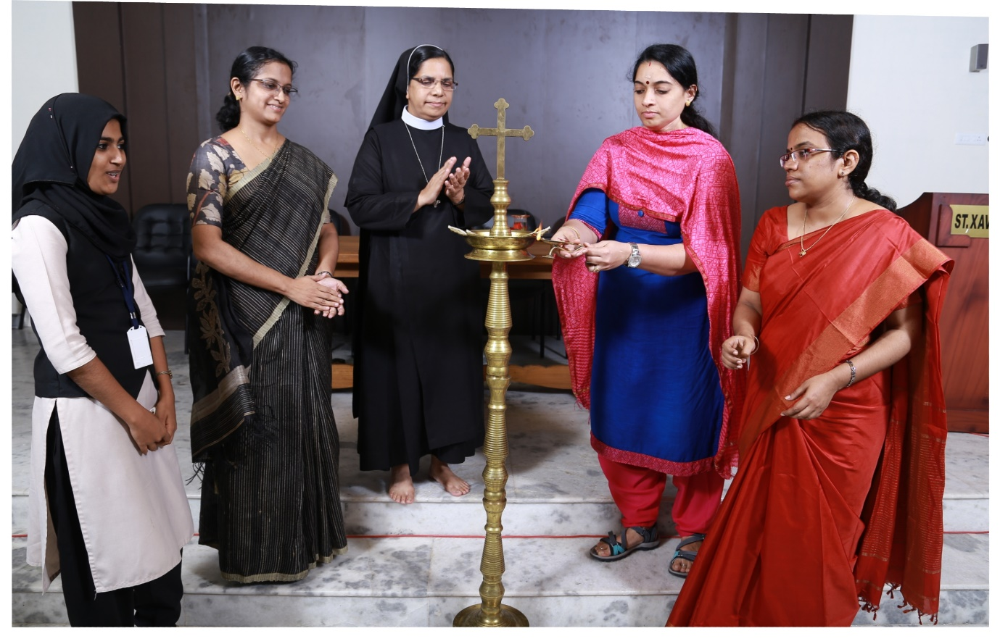
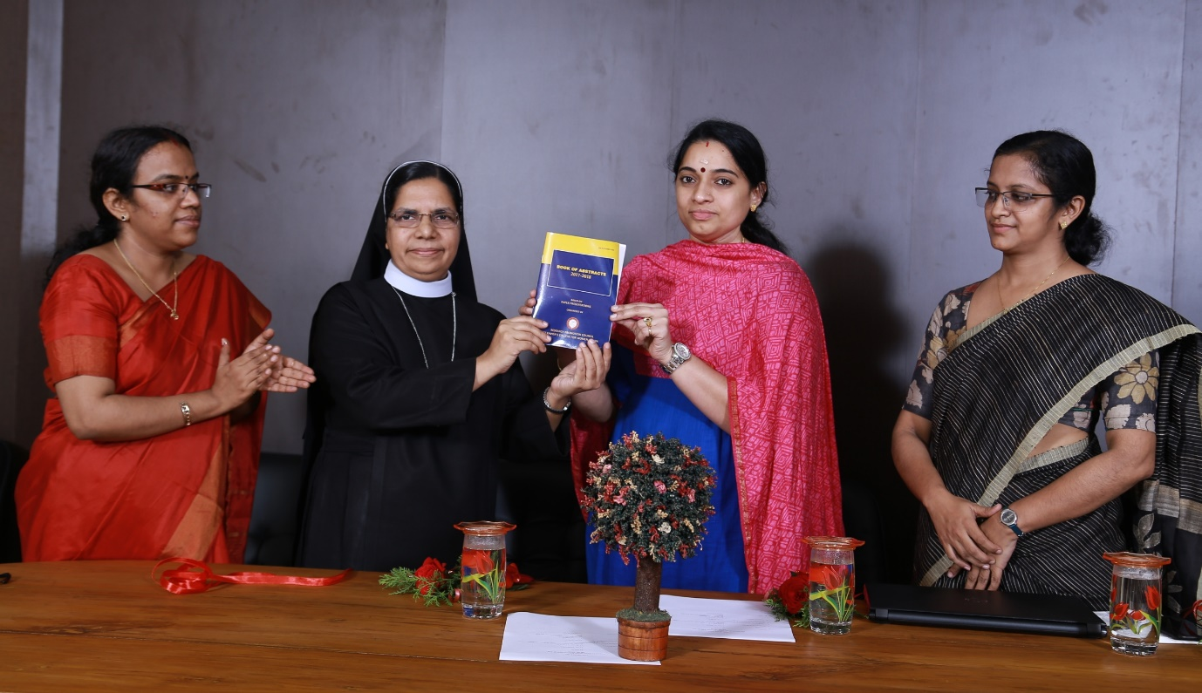

- Orientation Programme for faculty on Innovation, Incubation and Entrepreneurship on 26.06.18 by Dr. Venu P, Dean, Student affairs and innovation, incubation and Entrepreneurship, SCMS School of Engineering and Technology
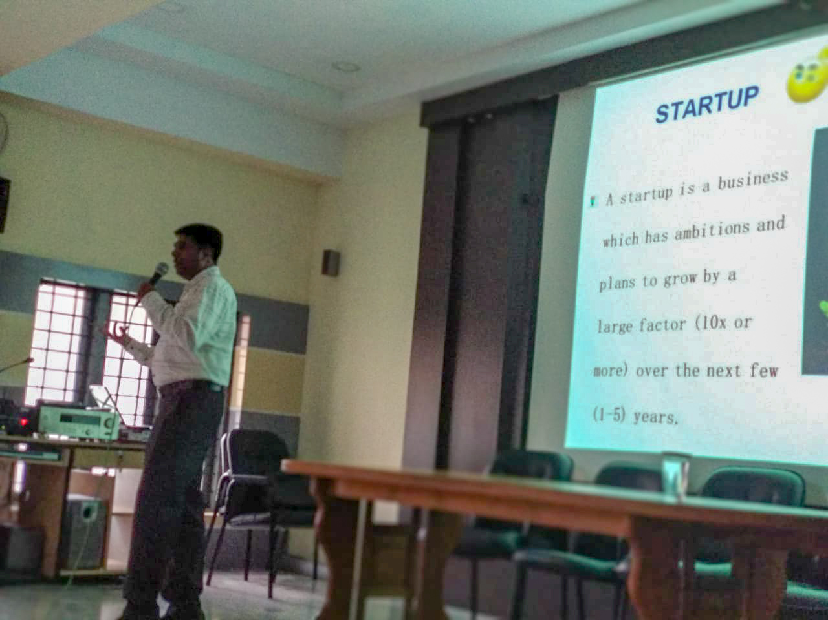

- Four paper presentation sessions were conducted- 12 papers both by faculty and students were presented during these sessions.
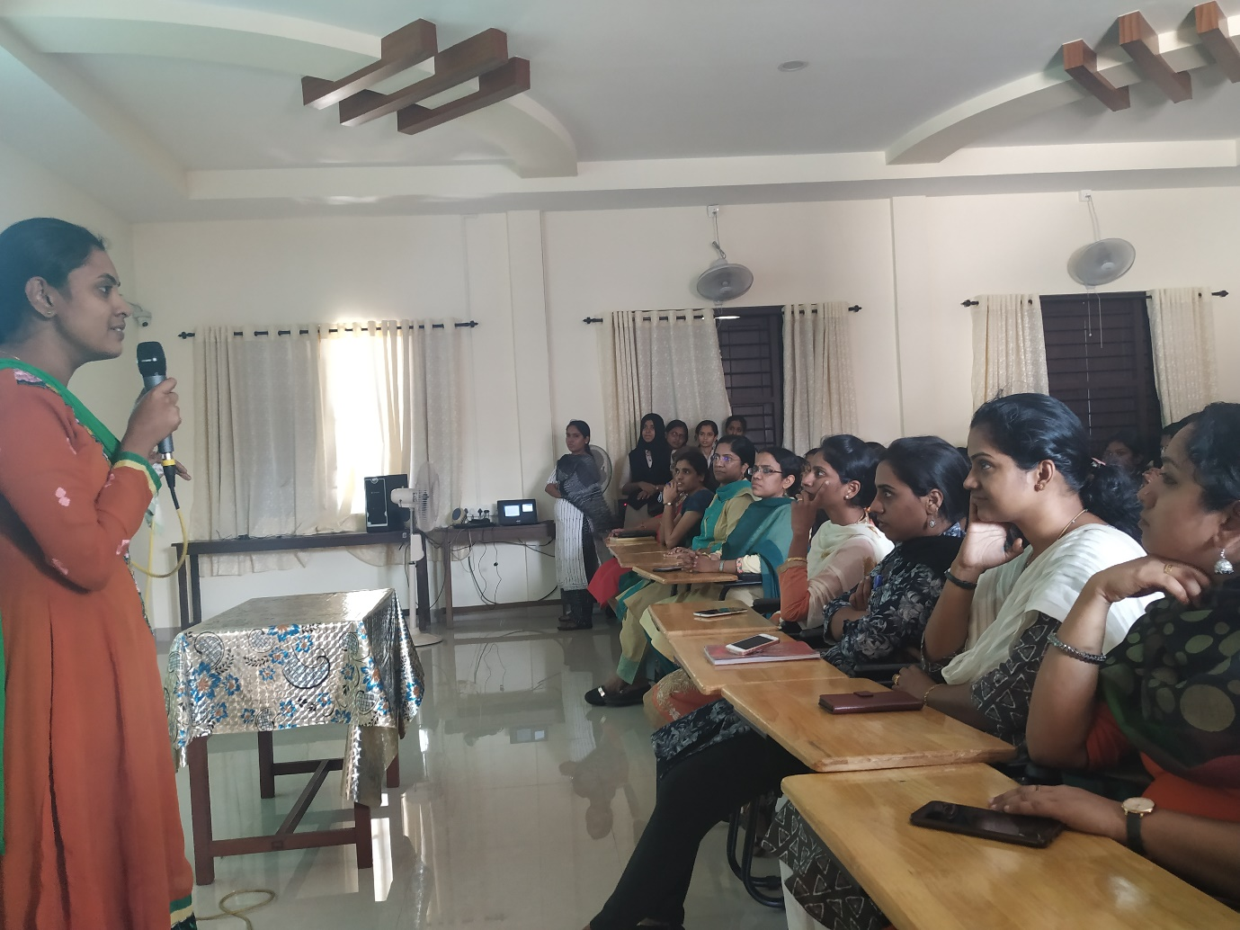

- Two issues of Peer reviewed multidisciplinary journal- DISCOURSE (ISSN 2321-0214) were published. Journal was recommended by M.G. University for inclusion in the UGC list of journals
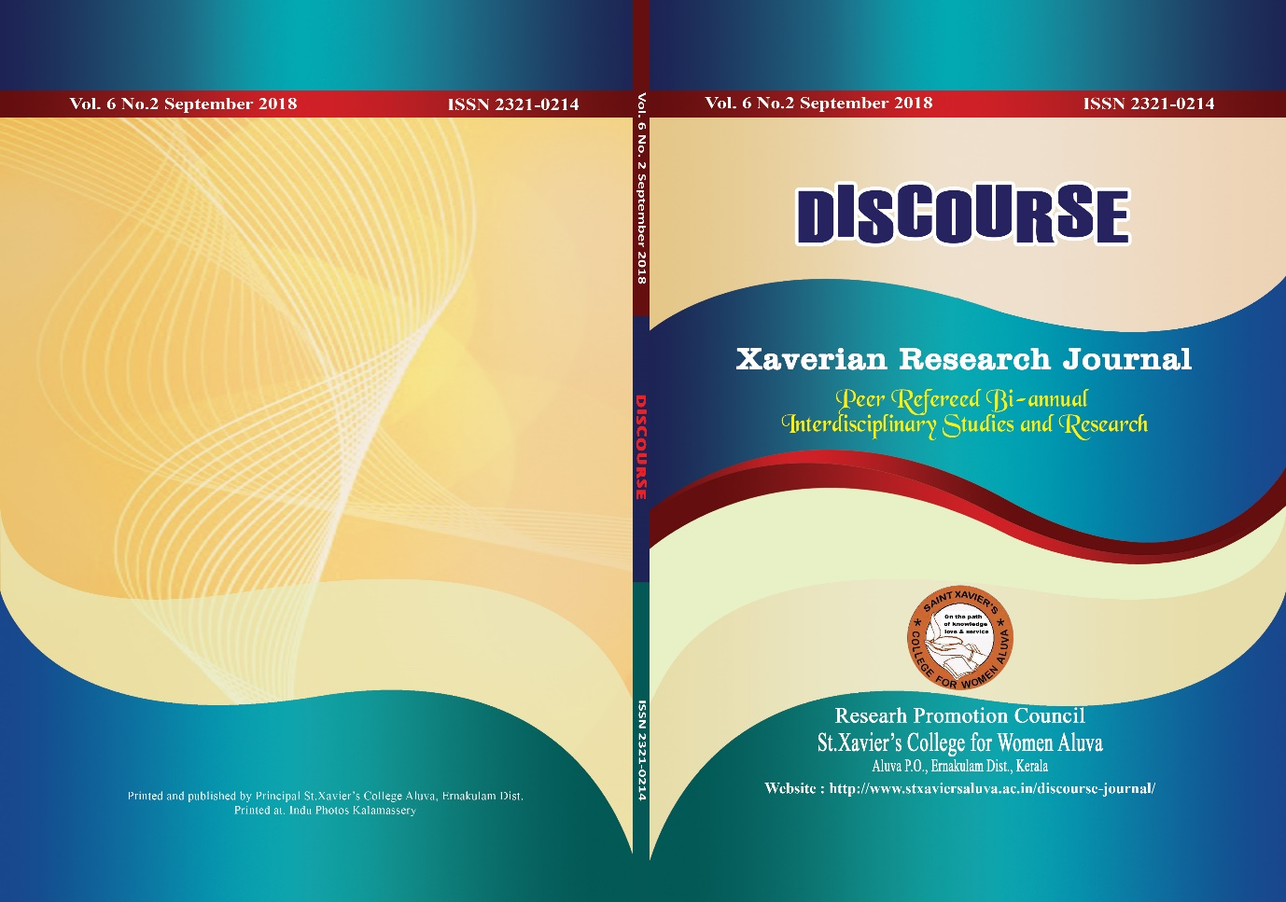

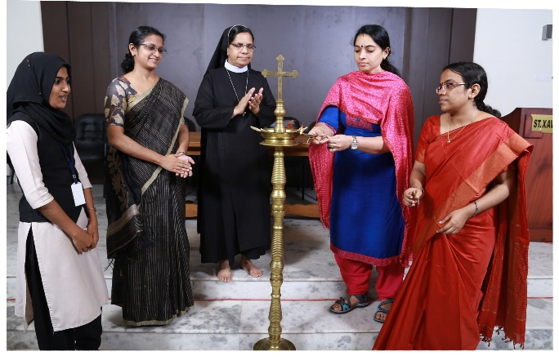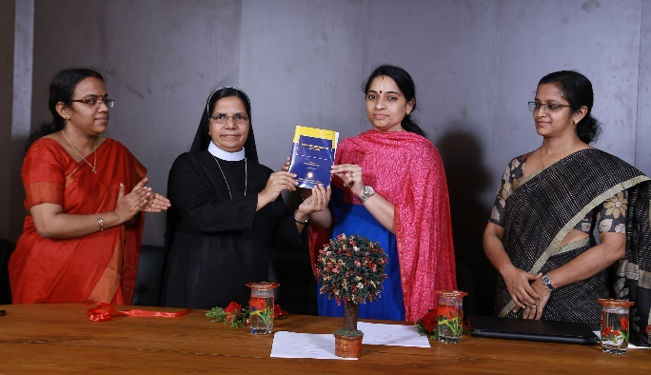
The inauguration of activities by Release of Book of Abstracts 2017-18
Dr. Sangeetha Mohan, Senior Scientist,
Sci Genome Labs (Pvt. Ltd.) Kakkanad

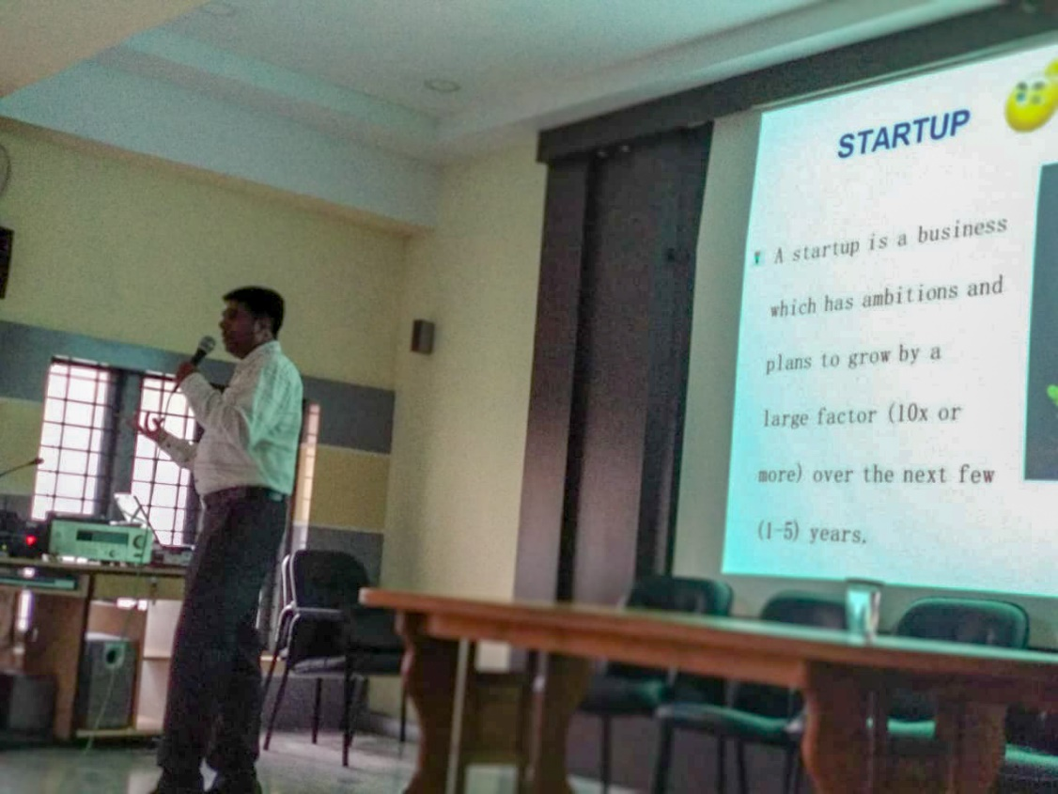
Orientation Programme for faculty on Innovation, Incubation and Entrepreneurship on 26.06.18 by Dr. Venu P, Dean, Student affairs and innovation, incubation and Entrepreneurship, SCMS School of Engineering and Technology
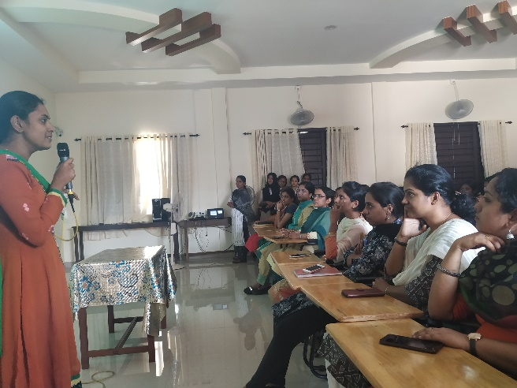
Paper presentation sessions
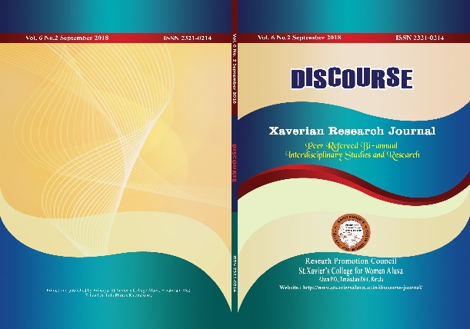
Xaveerian Research Journal- Discourse

