

1. Title of the program : Biodiversity awareness and extention program
2. Name of the Coordinator :Dr. Nisha P.
3. Organizing Department/Cell : Biodiversity club/Botany Dept.
4. Date : 27/02/2023 and 23.02.2023
5. Number of Members/Participants : 80 and 40
6. Objective of the Program/events : 1.to assess the present climate change and its

impact on indigenous species so that they can be conserved.

2. To create an awareness regarding biodiversity

3. to get first-hand information about biodiversity and the necessity to conserve the resources.

1. Description of the event : A. One day Workshop on

Session 1. "Climate - changge Redefining our relationship with nature"

Session2. Impact of climate change on Biodiversity

B. One day field trip to Ezhattumugham.

1. Duration of the activity : 2 days
2. Expected outcome of the activity :Conservation of existing biodiversity and

Sustainable use of its resources.

1. **Brochure:** 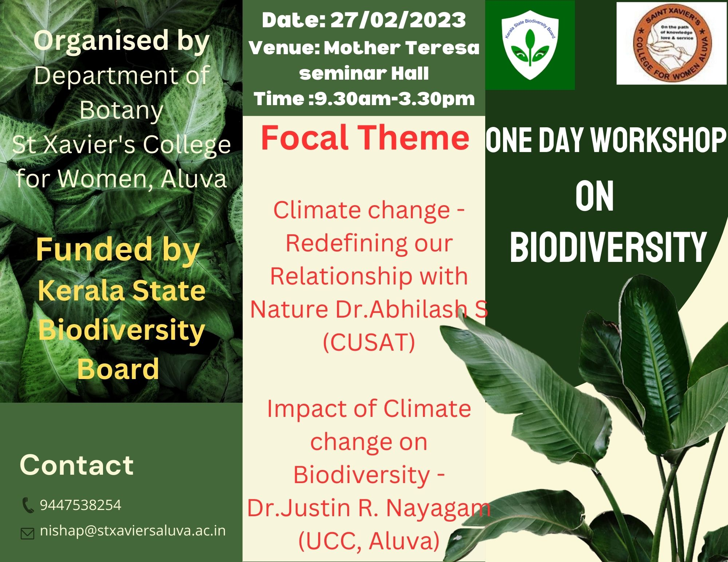
2. **Photos:**

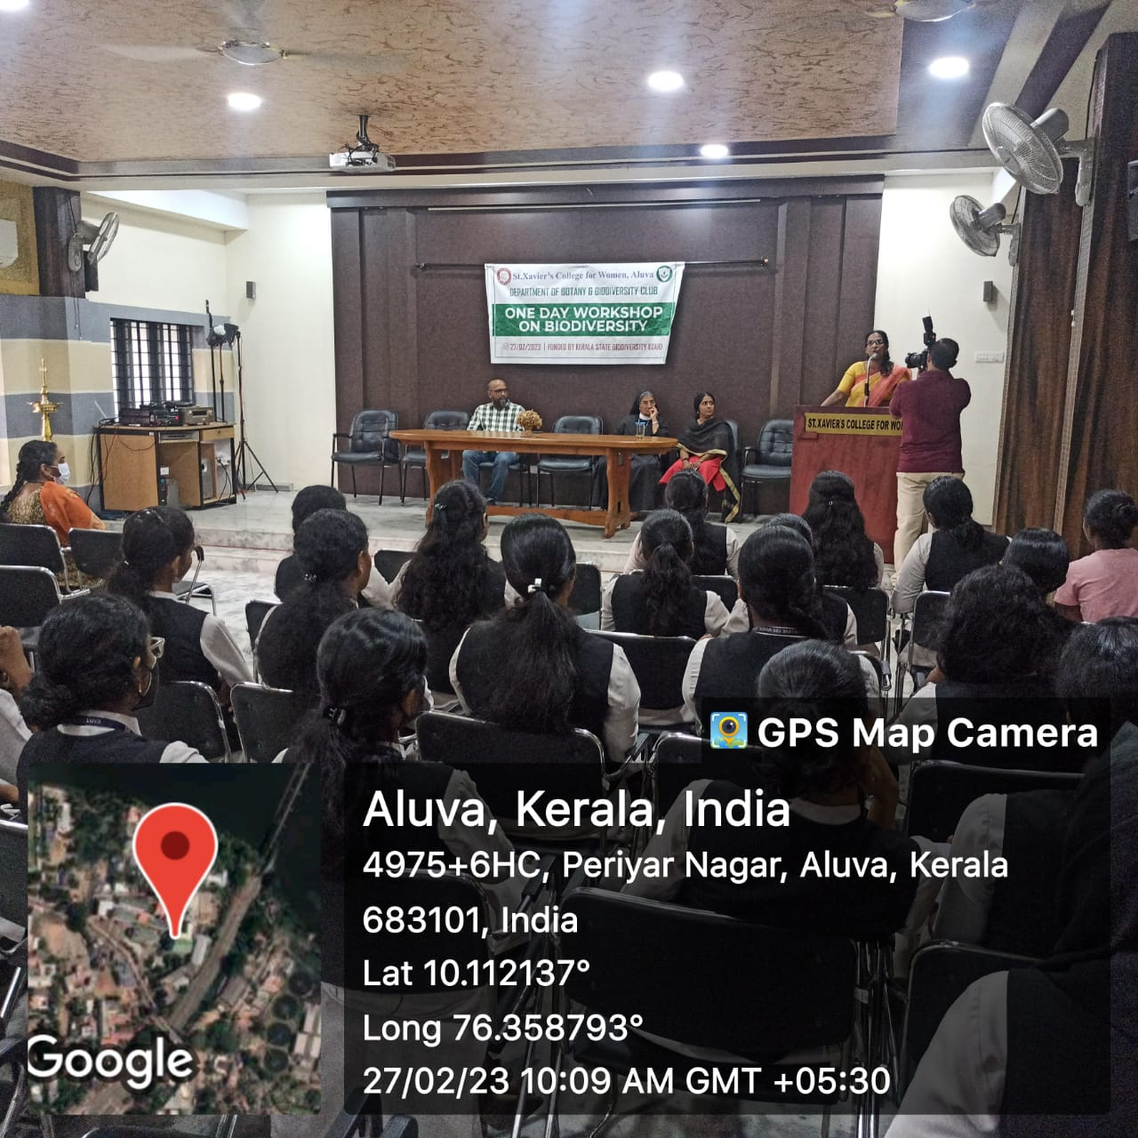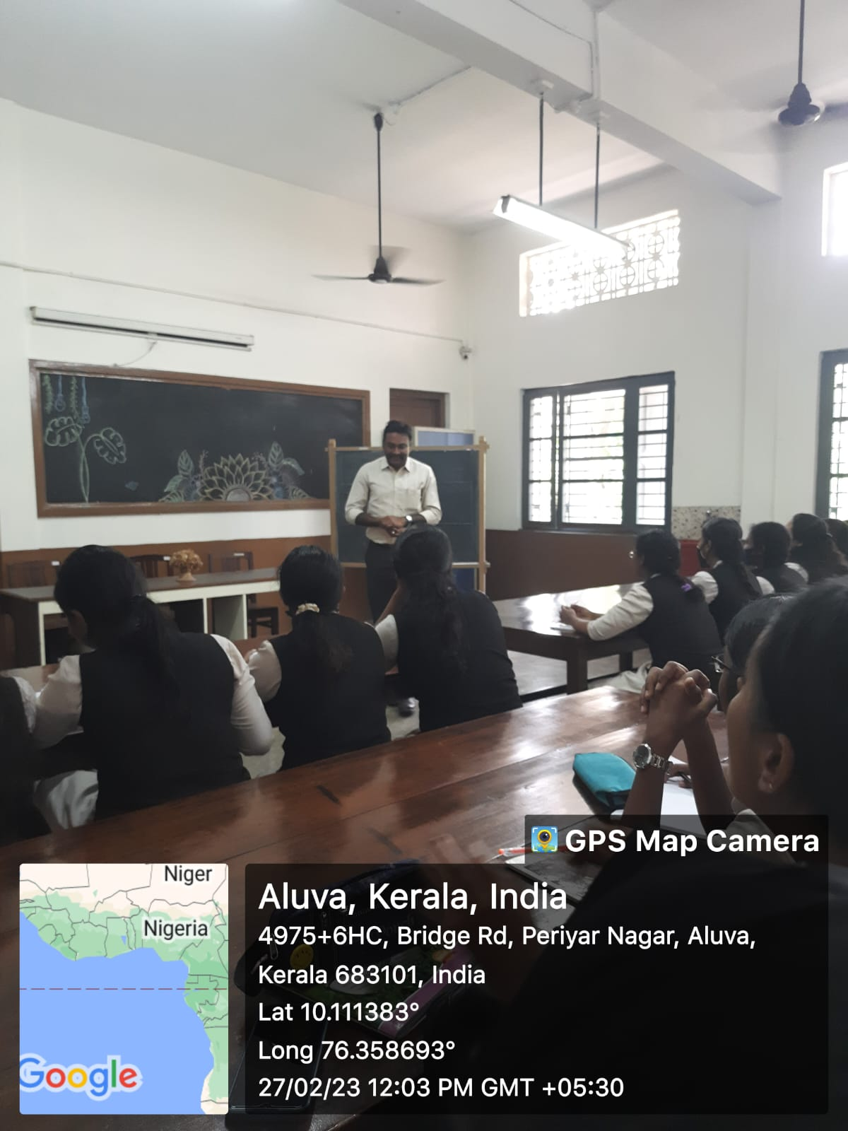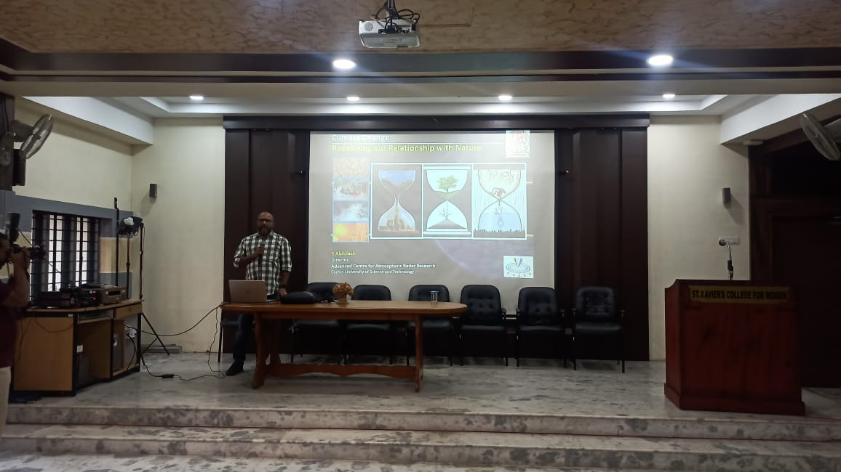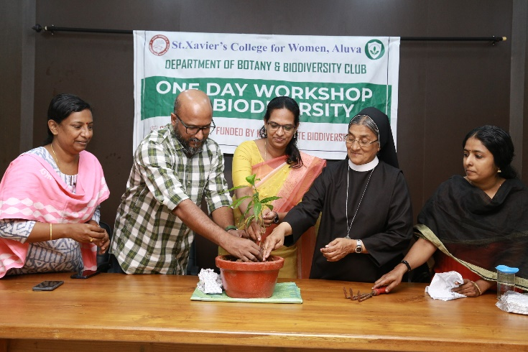

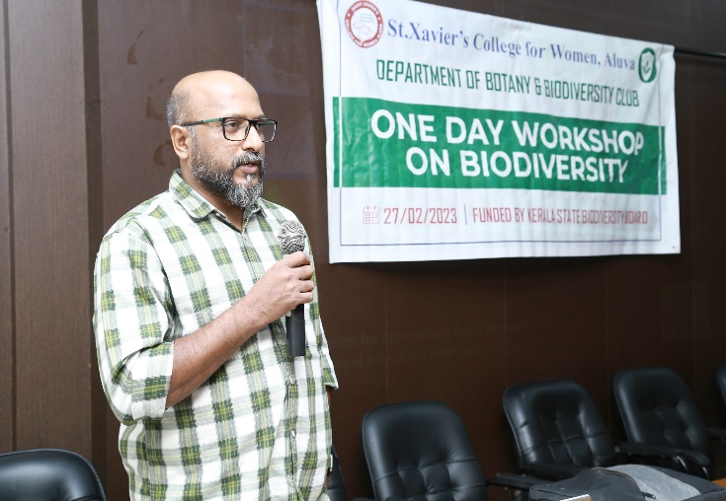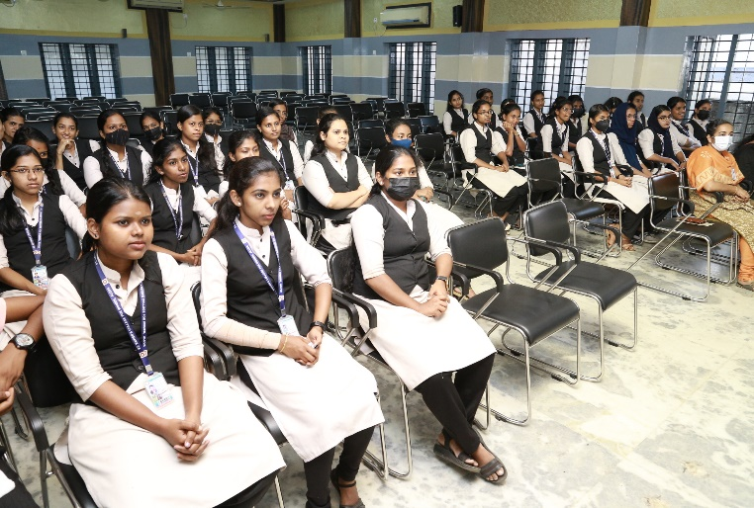

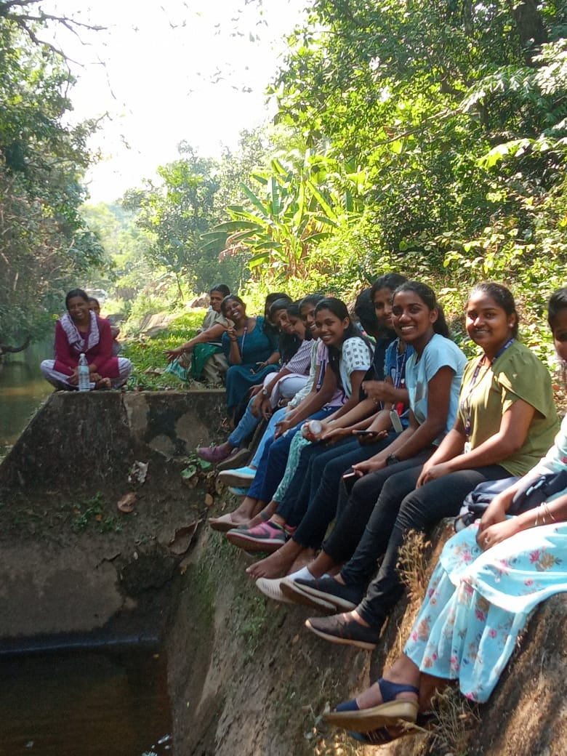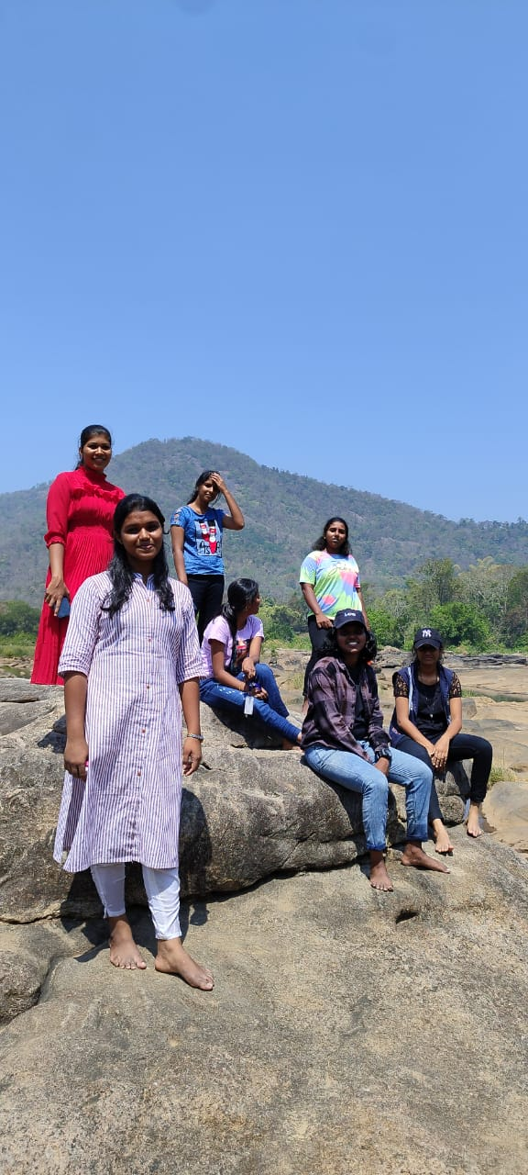

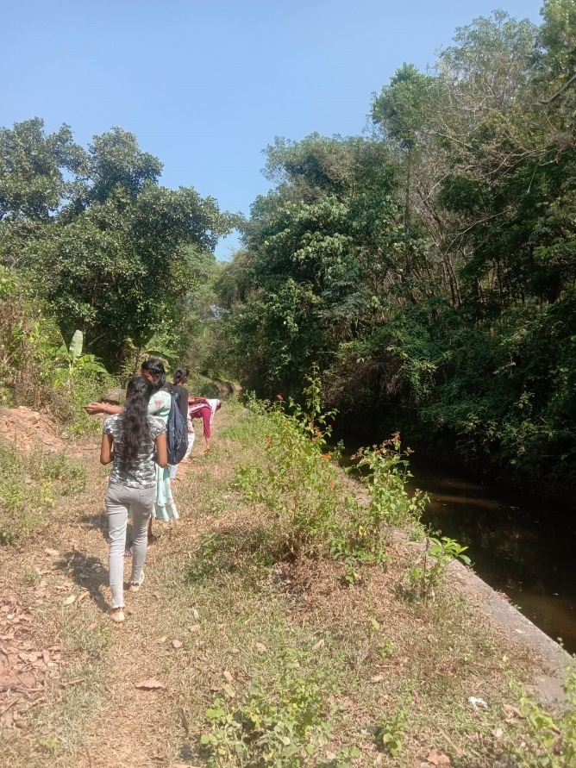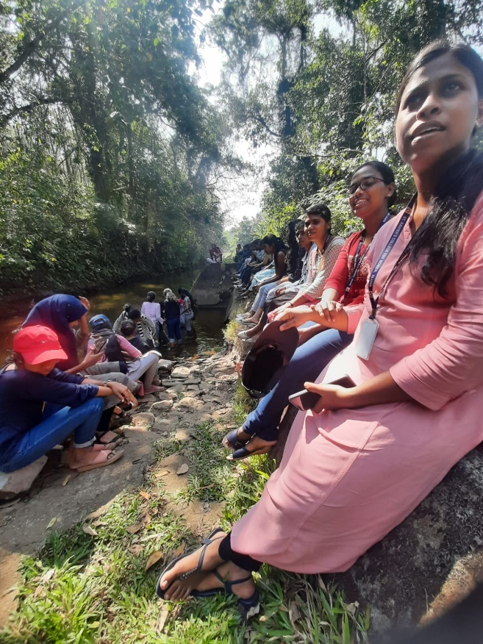

**Ezhattumugham field trip on 23/02/2023**

1. **Feedback**