

**DEPARTMENT OF BOTANY**

**LOTUS NATURE CLUB 2023-24**

* Mobile photography contest on the topic ‘Urban jungle’ was organised on 05/06/23 as part of celebrating World environment day 2023. Jointly organised by Lotus Nature club and Painting & Photography club.

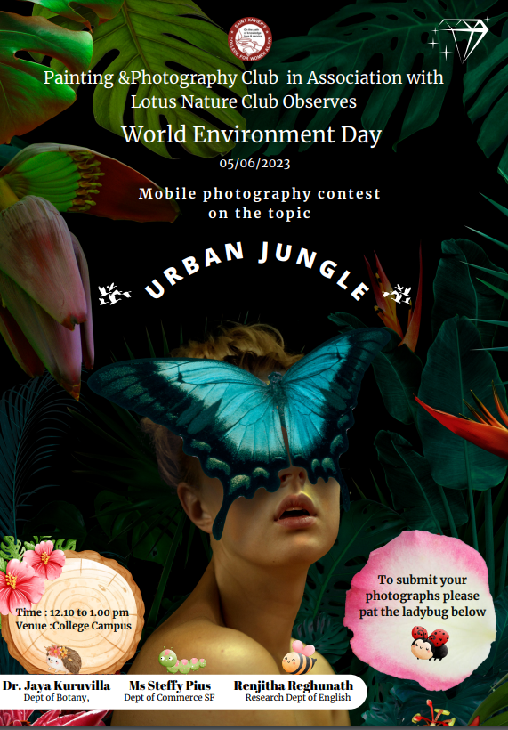

* 10 students from final year Botany attended a training class on Pet care organized by Livestock management training centre, Aluva on 08/02/24

